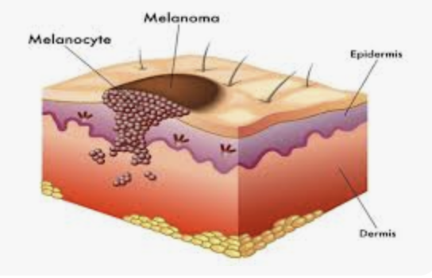
Lawrence Charles Parish, M.D., M.D. (Hon), F.R.C.P.Edin

Jennifer L. Parish, M.D.

1845 Walnut Street, Suite 1650
Philadelphia, PA 19103

TEL: 215.563.8333 FAX: 215.563.3044

Individual Highlights:
Inside Story 2
Inside Story 3
Inside Story 4
Inside Story 5
Inside Story 6
Inside Story 7
Last Story 8

Special Interest Articles:

- Briefly highlight your point of interest here.
- Briefly highlight your point of interest here.
- Briefly highlight your point of interest here.


Melanoma
A larger form, known as the bathing trunk nevus, is often removed, as there is a possibility that a melanoma may be hidden within it.

Melanoma
Melanoma is a type of skin cancer that can have a seemingly innocent appearance. It may be flat or raised, may bleed easily, and often grows rapidly. The ABCDs is good way for identifying a possible melanoma.
- Asymmetry: one half does not match the other side
- Border: ragged or irregular.
- Color: variable throughout.
- Diameter: greater than a pencil eraser
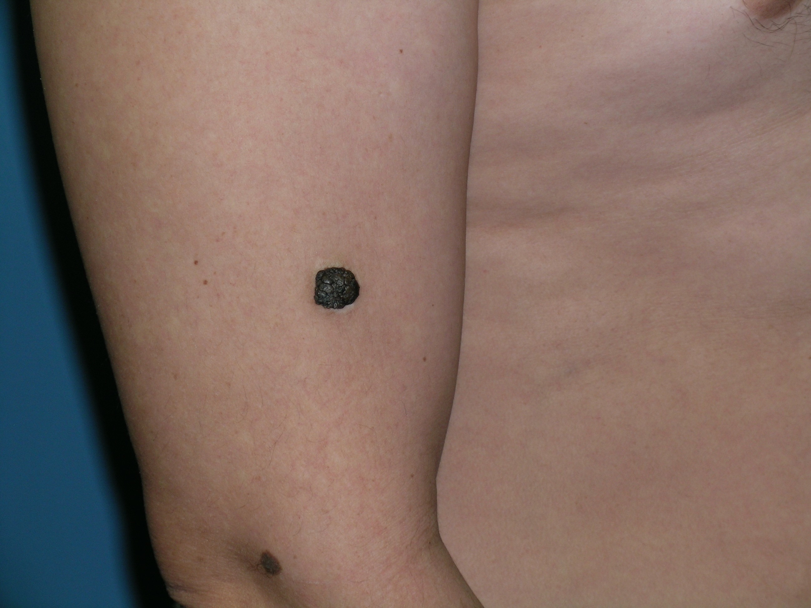

This type of melanoma requires immediate attention, not watchful waiting, if a bad outcome is to be avoided.

Nevi
What is a mole, sometimes known as a beauty mark? A nevus (plural nevi) is a flat to raised, colored, red, or brown lesion that generally lasts around thirty years. There are always some nevi appearing and some disappearing. Most people have ten to forty nevi on their bodies.

Both compound cellular and intradermal types are perfectly benign and are also easily removed. To be considered is the dysplastic type that may become a skin cancer.
A dysplastic nevus should be removed by cold steel surgery so that it may be studied in the dermatopathology laboratory. It can be flat or raised, bleeds easily, and often grows rapidly. Remember the ABCDs for identifying a possible melanoma.
Some may call a wart or a seborrheic keratosis (liver spot, old age mark) a mole. Both are benign lesions, but when there is doubt, an office consultation is needed.
A different type of nevus is the congenital nevus that is present almost from birth. It is often brown, but some are red. When it is small, it is generally safe; however, the
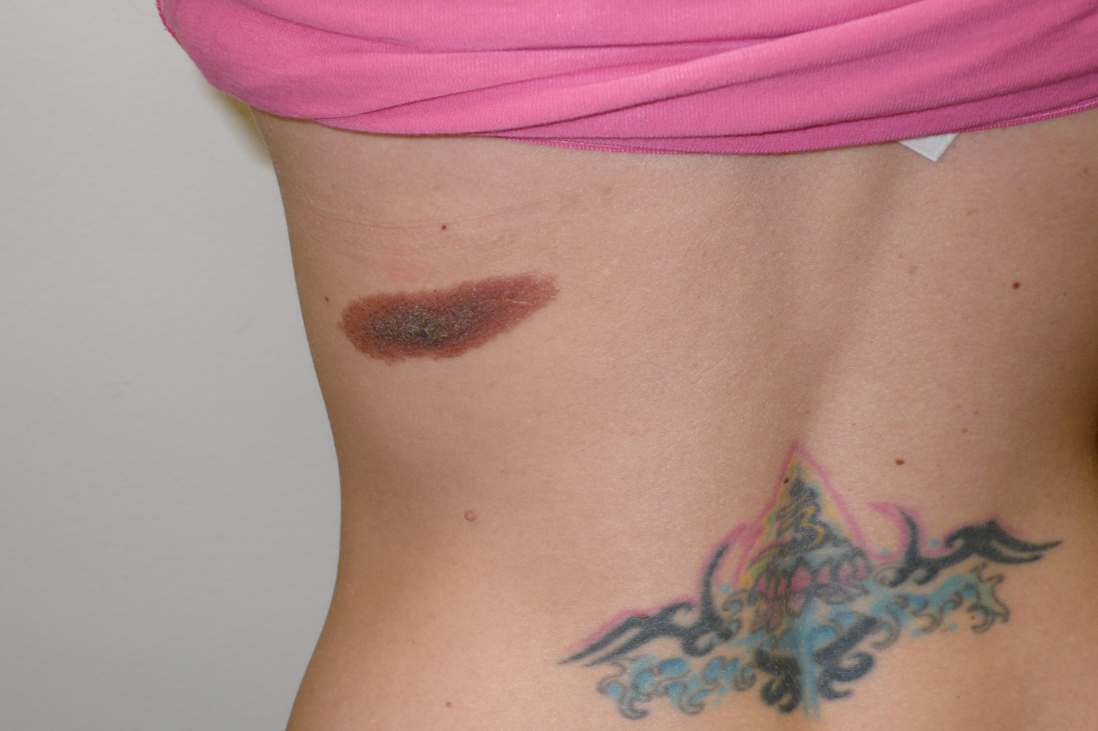
Congenital Nevus
Compound Cellular Nevus
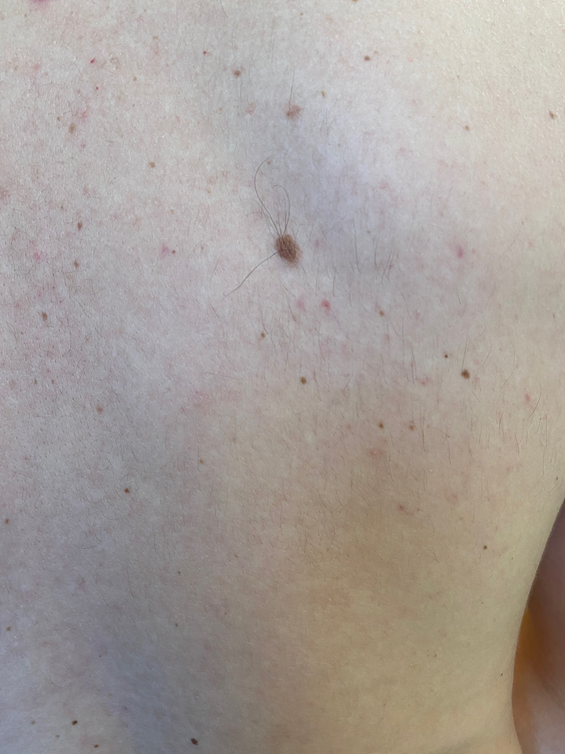


Parish Dermatology

Newsletter 2025

Volume 20, Issue 3

Moles and Nevi

