Lawrence Charles Parish, M.D., M.D. (Hon)
Jennifer L. Parish, M.D.

1845 Walnut Street, Suite 1650
Philadelphia, PA 19103

Tel: 215.563.8333. Fax: 215.563.3044.
www.parishdermatology.com

TEL: 215.563.8333 FAX: 215.563.3044
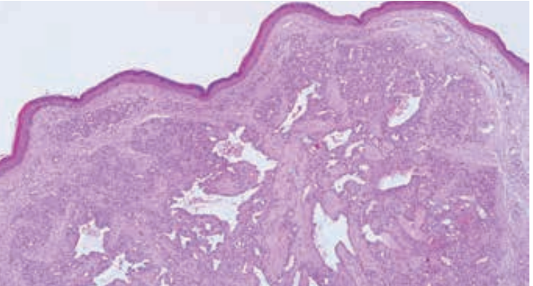

Individual Highlights:
Inside Story 2
Inside Story 3
Inside Story 4
Inside Story 5
Inside Story 6
Inside Story 7
Last Story 8

Special Interest Articles:

- Briefly highlight your point of interest here.
- Briefly highlight your point of interest here.
- Briefly highlight your point of interest here.

Instead of staying flat on the skin, these cells have invaginated or grown inwards, creating a cyst during cell replacement. It is the wall of the cyst that keeps the contents intact. Once, it is has been interfered with, the contents are absorbed, and the cyst will disappear.

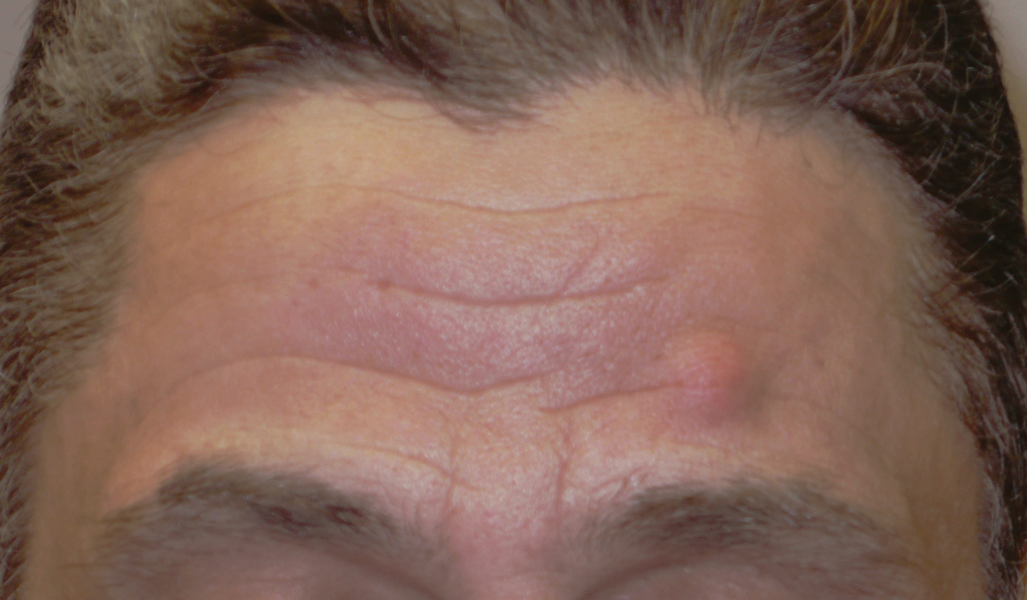

Sometimes, a KC can become infected; often, this process interferes with the wall of the cyst, and the cyst disappears. Treatment includes: a) injecting with Kenalog®, b) freezing, c) incising (puncturing the cyst and expressing the contents and sac), d) excising (removing the cyst and sac), or e) no treatment.

Cherry Angiomas
These are benign red dots that range from 1 mm to a few mm. They can appear anywhere on the body but usually on the trunk and often begin to develop after the age of 30.
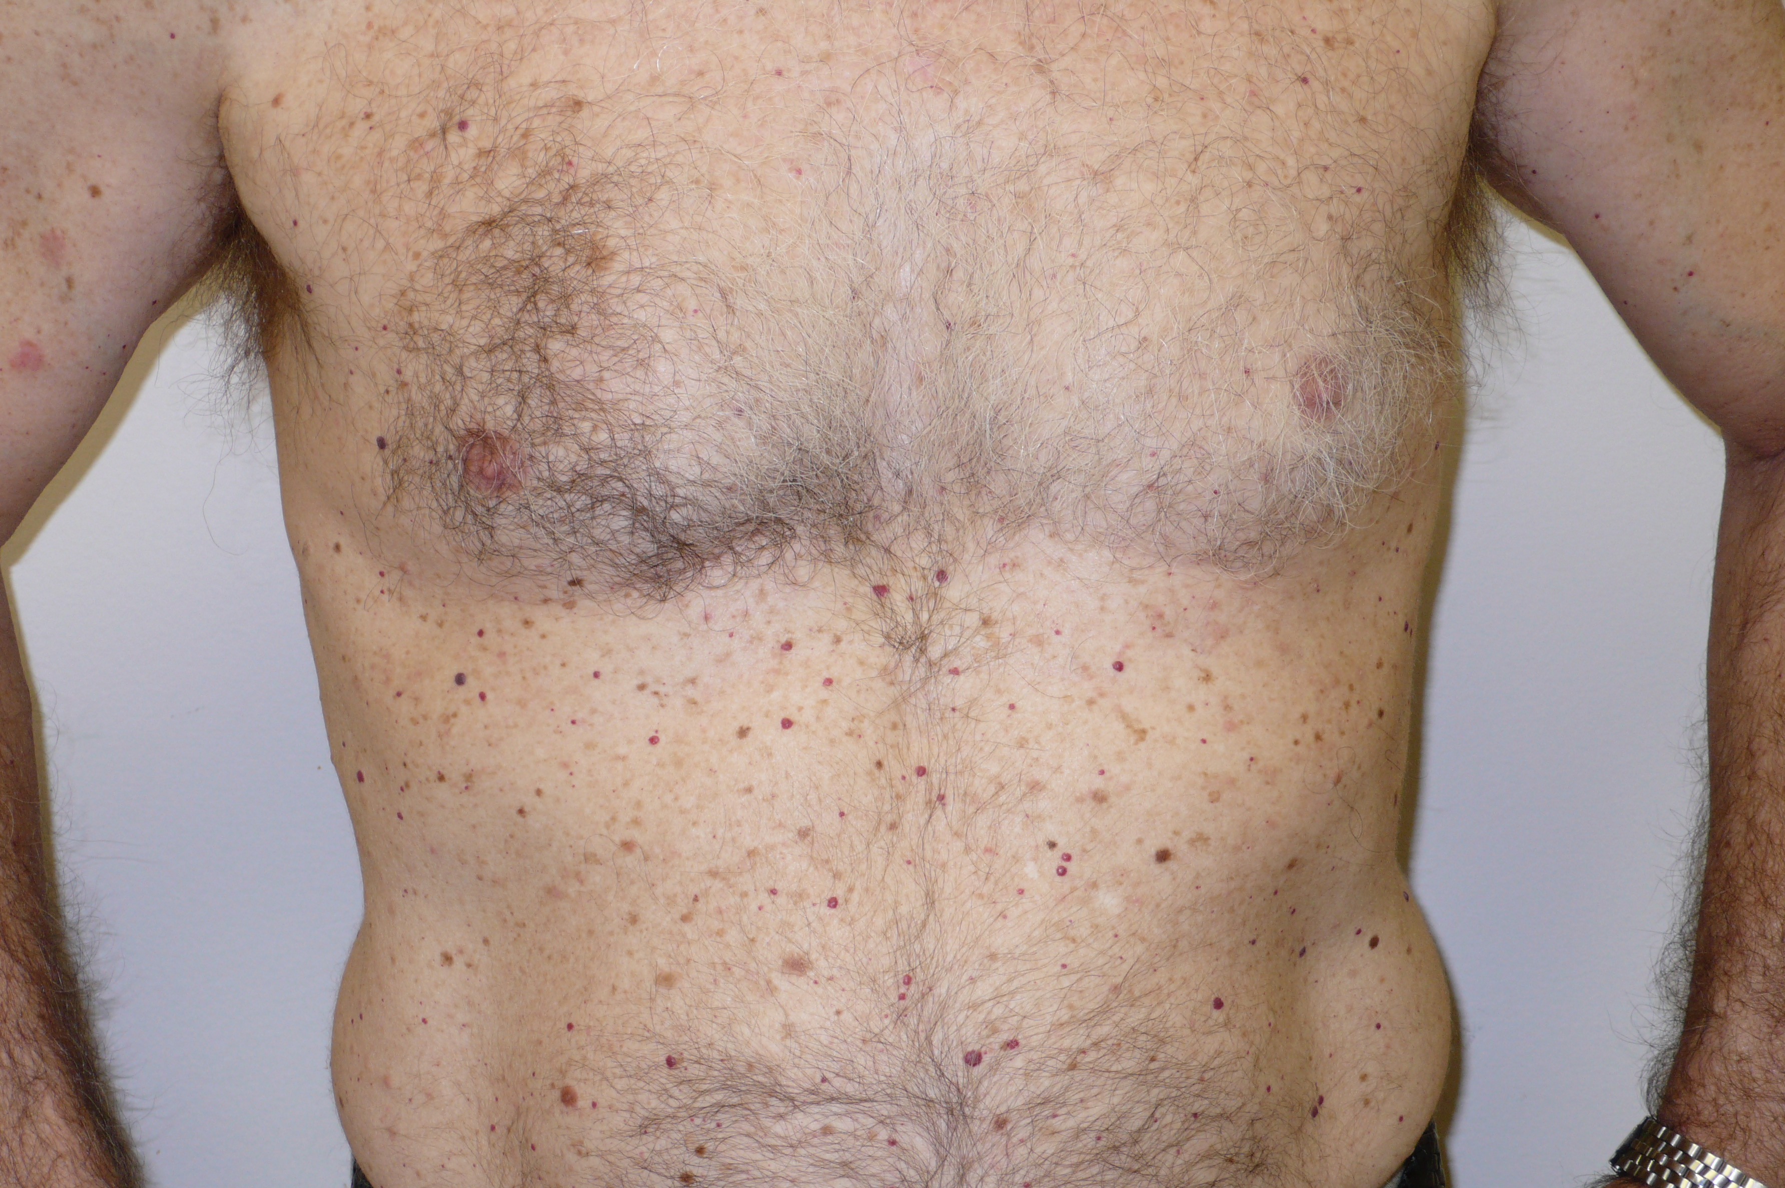

Also known as Campbell de Morgan spots, they are an entirely benign, like a bleb on a tire wall, and easily destroyed by electrodesiccation or a scissor snip.
Cherry Angioma

Lumps, Bumps, and Barnacles: I
Lumps
The skin, as the largest organ of the body, is subject to more attention than any other part of the body. Sun, water, cold, and heat are just some of the elements to which the skin might be exposed. Not all these environmental encounters may change what is unwanted or worrisome.
Seborrheic Keratoses (SKs)
These are brown to red, sometimes scaly, marks that occur as one ages. While sometimes referred to as old age marks, senile spots, or liver spots, these represent the accumulation of debris and are unrelated to any sun exposure. 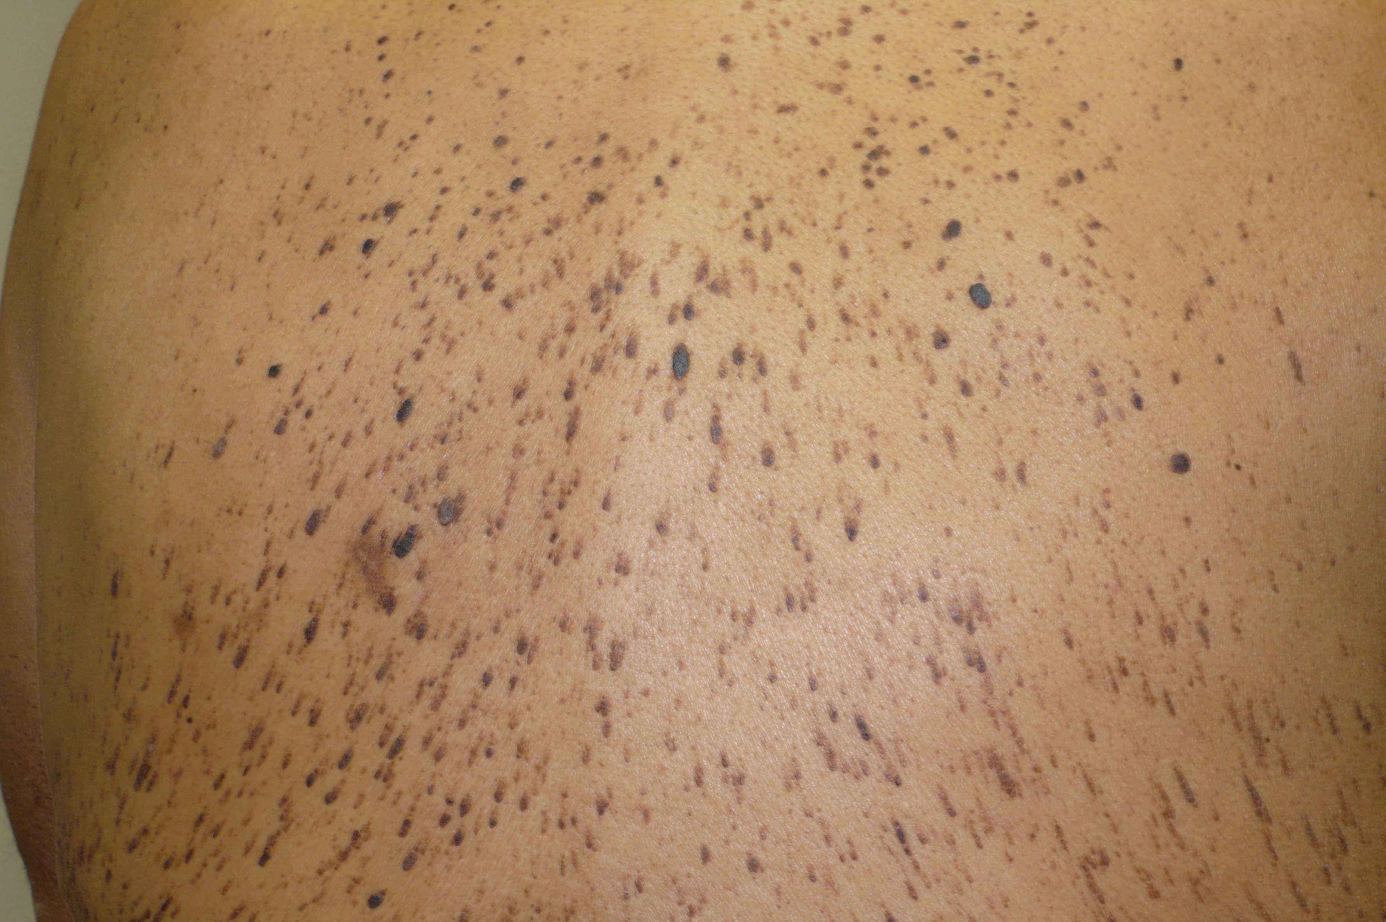
SKs may be itchy or even painful, when they are scratched or picked. Unsightly – yes, worrisome – sometimes, but they do not represent cancer. SKs rarely mimic skin cancer.
They can be treated any number of ways, ranging from cryosurgery (freezing with liquid nitrogen) (LN₂), peeling (applying a chemical), to scraping (curetting), or just forgetting about them.
Keratinous Cysts (KC)
These bumps can appear almost anywhere on the body from the face to the arms or the trunk and are benign. They have been called sebaceous cysts. wens, or epithelial cysts. These cysts are not malignant, often being unsightly bumps.
Within a 28-day period, every skin cell has been

Constant scratching and rubbing leads to lichenification, which is thickening of the skin. Sometimes, the constant rubbing results in bacterial infection with oozing, crusting, and pustules.
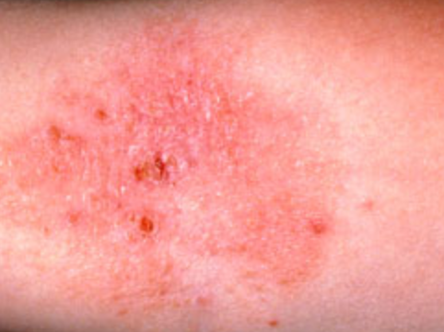

Nummular dermatitis frequently appears on the neck, but it can be found anywhere on the body. Sometimes, the itching and redness occurs in just one place, but other times, there can be several areas of dermatitis.
OTHER DIAGNOSES
Nummular dermatitis may look much like other eczematous conditions, such as neurodermatitis, atopic dermatitis, or contact dermatitis. It may even be confused with ringworm (tinea corporis), where there are central clearing and elevated borders.

Treatment
Nummular dermatitis is readily treated with topical steroids. It is important not to apply alcohol or hydrogen peroxide, as these irritants will aggravate the skin. Also, do not scrub the skin; the less soap the better.



Irritant Contact Dermatitis due to Scrubbing with Soap
Acne keloidalis
Keloid seen microscopically
Microscopic view of a keloid
Keloid due to ear piercing

Allergic reaction to nickel in the jean rivet

Allergic reaction to tattoo ink

Parish Dermatology

Newsletter 2025

Volume 17, Issue 2

