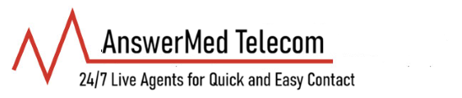
Recurring Credit Card Authorization:
I, the undersigned Cardholder, hereby authorize AnswerMed Telecom, Inc. (the "Merchant") to charge my credit card account indicated below for recurring payments on a regular basis.
This authorization is for recurring charges related to telecommunication services, billing, or other agreed-upon charges as outlined in invoice with Answermed Telecom, Inc.
Cardholder Information:
Name (as it appears on the card): _______________________________________
Billing Address: City, State, ZIP:______________________________________________
Phone: ______________________________ Email: ______________________________
Credit Card Information Card Type: ☐ Visa ☐ Mastercard ☐ Discover ☐ American Express ☐ Other:
Card Number: _______________________________________________
Expiration Date: _______________ CVV/Security Code: _______________
This authorization will remain in effect until I notify AnswerMed Telecom, Inc. in writing, calling or by email to billing@answermedtelecom.com to revoke or cancel it, or until the service Terminates. I understand that I may revoke this authorization at any time by contacting the Merchant.
I understand that:
- Charges will appear on my card statement as from "AnswerMed Telecom, Inc." or a similar descriptor.
- I will receive invoices/receipts for each charge as required.
- This authorization complies with applicable card network rules for recurring payments.
- I have the right to dispute any unauthorized or incorrect charges with my card issuer.
Cardholder Acknowledgment and Signature I have read, understand, and agree to the terms above. I authorize the recurring charges as described.
Signature: _______________________________ Date: __________
AnswerMed Telecom, Inc. 15 North River Rd Tolland, CT 06084 Telephone: 860-871-4712 Email: billing@answermedtelecom.com Fax: 860-530-5375 Website: answermedtelecom.com

