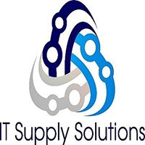

Quality, Environmental, Health and Safety Policy

IT Supply Solutions is committed to provide solutions for the responsible, effective management and removal of end-of-life electronic assets in a manner protecting the environment, worker health and safety, our clients and our community.

- IT Supply Solutions is committed to continual improvement and customer satisfaction.

- IT Supply Solutions is committed to the prevention of pollution and prevention of injury and ill health.

- IT Supply Solutions is committed to comply with applicable legal and other stakeholder requirements relative to the quality, environmental and health and safety aspects of our business.

- IT Supply Solutions is committed to providing a framework for setting and reviewing quality, environmental, health and safety goals.

- IT Supply Solutions is committed to manage used and end of life electronic equipment based on a reuse, refurbishment, recovery, disposal hierarchy including onsite and downstream materials management throughout the recycling chain.

- IT Supply Solutions is committed to manage Focus Materials throughout the recycling chain to final disposition with due diligence to protect our environment.

- IT Supply Solutions is committed to continuous improvement achieved through monitoring of goals and rigorous evaluation of our management system.

- IT Supply Solutions is committed to communicating and reinforcing this policy throughout our company, to all persons working for or on behalf of the organization as well as, to our customers, our suppliers and to the public.

Marc Kaiser 12-13-2024
(Marc Kaiser), Partner Date

