IMG PHYSICAL THERAPY

805 N. Richmond St., Suite 103 Fleetwood, PA 19522

IMGPT.COM 610-944-8140
Chris Gordos, DPT Center Manager
Eric Parrish, MPT Director of Rehabilitation
Andrea Miller, DPT Balance and Pain Specialist

4 Simple Knee Stretching &

Strengthening Home Exercise Sheet

Rehabilitation of the knee may take an extended period of time. A loss of strength, range of motion, and use is common after an injury or surgery. Your strength, range of motion, and use of the knee can be regained. It may become frustrating at times, but you can be successful with hard work, patience, and listening to your body.

When you are exercising on your own at home there are some things to remember….

* Any specific exercise that causes pain, especially sharp knife like pain, is hindering the healing process for your injury and should be modified or discontinued until you notify your therapist.

* Increased swelling after exercise indicates that the exercise may be too difficult or it is not being done correctly. Be sure to ice that area of swelling and use a compression wrap as needed.

* Re-injuries during the rehabilitation process will slow your progress. If you
get recurring pain either lower the resistance; lower the number of sets or
repetitions; or reduce the range of motion to avoid the area of pain.

∗ You should experience muscle soreness, dull ache, fatigue, and stretching sensations, but the
exercises should not increase the pain or swelling.

* When in doubt about how much weight to use for exercises, guess low. It is
safer and easier to add weight than to hurt yourself with too much weight.

* Consult your Physician or Physical Therapist if any problems arise or if you
have any questions regarding an exercise. It is better to make sure that you are
doing an exercise correctly than to cause further injury by doing an exercise
incorrectly.

These exercises are to be done 3-5 times a week.
Perform 10-30 seconds holds for 3-10 repetitions for stretching exercises
Perform 2 sets of 15 repetitions for strengthening exercises

Ice for 15 minutes after exercise and at the end of the day.
Do not ice before exercising.

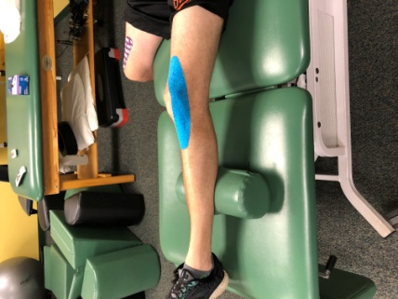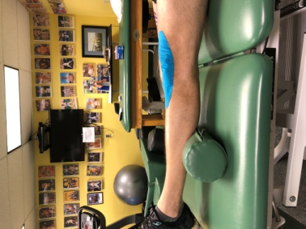

Quad Sets: Tighten the top of your thigh muscles by pushing your knees down into the bed. Hold for 10 seconds. Do for 10 reps..

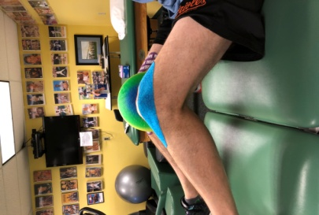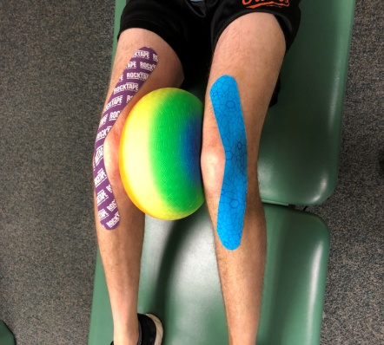

Ball Squeezes: With ball or pillow between knees, squeeze your knees together. Hold for 10 seconds. Do 10 Reps.

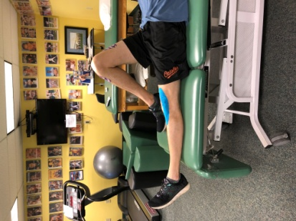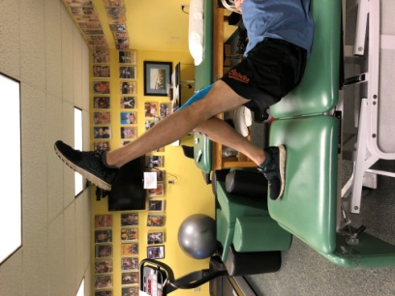

Straight Leg Lifts: Tighten muscles on front of the leg, then lift the leg to equal height of the bent other leg, keeping your knee locked straight. Slowly lower. Repeat 10-15 times for 1-3 sets.

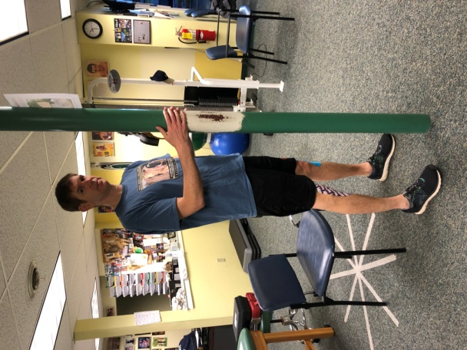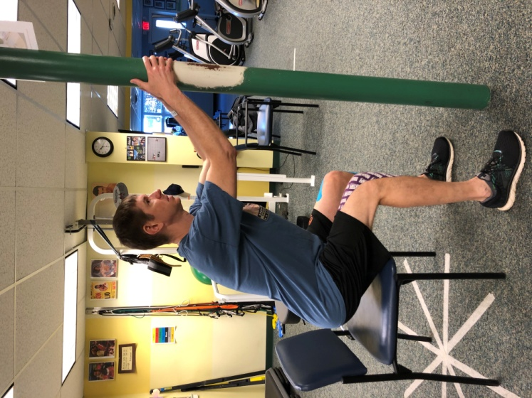

Minisquts: Keeping your feet flat on the floor and shoulder width apart, squat as low as comfortable. Make sure you keep your back straight. Bend at the hips. Aim your butt for a chair. Your knees should not move forward as you “sit in the chair.” Use support as necessary. Perform 2 sets of 15.

