IMG Physical Therapy

805 N. Richmond St., Suite 103 Fleetwood, PA 19522 610-944-8140

WWW.IMGPT.COM
Chris Gordos, DPT Andrea Miller, DPT
Eric Parrish, MPT Center Manager

Ankle Injury Home Exercise Sheet

Rehabilitation of the lower extremity may take an extended period of time. A loss of strength, range of motion, and use is common after an injury or surgery. You may also experience some swelling and popping noises. Your strength, range of motion, and use of the ankle can be regained. It may become frustrating at times, but you can be successful with hard work, patience, and listening to your body.

When you are exercising on your own at home there are some things to remember….

* Any specific exercise that causes pain, especially sharp knife like pain, is hindering the healing process for your injury and should be modified or discontinued until you notify your therapist.

* Increased swelling after exercise indicates that the exercise may be too difficult or it is not being done correctly. Be sure to ice that area of swelling and use a compression wrap as needed.

* Re-injuries during the rehabilitation process will slow your progress. If you
get recurring pain either lower the resistance; lower the number of sets or
repetitions; or reduce the range of motion to avoid the area of pain.

* You should experience muscle soreness, dull ache, fatigue, and stretching sensations, as long as
the exercises do not increase the pain or swelling.

* When in doubt about how much weight to use for exercises, guess low. It is
safer and easier to add weight than to hurt your self with too much weight.

* Consult your Physician or Physical Therapist if any problems arise or if you
have any questions regarding an exercise. It is better to make sure that you are
doing an exercise correctly than to cause further injury by doing an exercise
incorrectly.

These exercises are to be done 1 time per day or 3 to 5 days per week.
**Perform 2 sets of 15 repetitions for strengthening exercises**
**Stretch for 3-10 repetitions holding 10-30 seconds each time.**

Ice for 15 minutes after exercising and at the end of the day.

Ankle ABCs  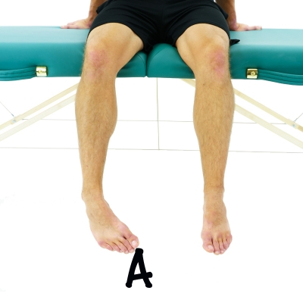 | While in a seated position, write out the alphabet in the air with your big toe.  Repeat 1 Time Hold 1 Second Complete 3 Sets Perform 2 Times a Day
Towel Curls-Towel Scrunches  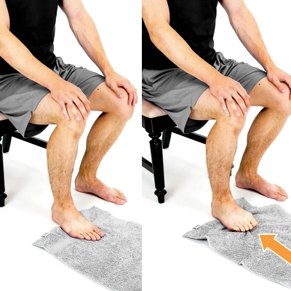 | While seated, use a towel and draw it back towards you using your toes. Curl your toes inward.  Repeat 15 Times Complete 2 Sets Perform 1-2 Times a Day
Calf Stretch with Towel  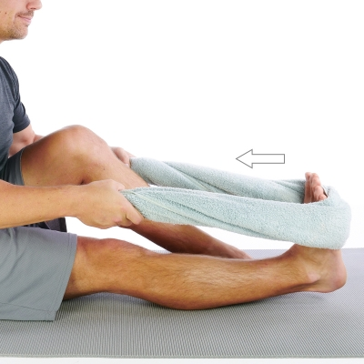 | While in a seated position, place a towel around the ball of your foot and pull your ankle back until a stretch is felt on your calf area.  Repeat 1 Time Hold 30 Seconds Complete 3 Sets Perform 2 Times a Day
Ankle 4 way with Theraband  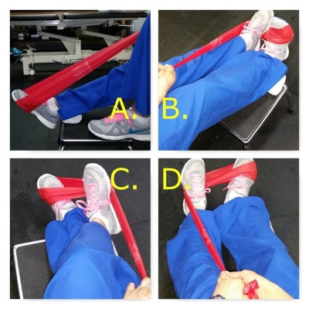 | All theraband exercise is slow and controlled. Do not let the band "bounce" back.  A. Plantarflexion: "gas pedal." Keep knee straight.Band around "ball of foot" and press it away as far as possible and slowly return to neutral. Repeat.  B. Dorsiflexion: start in neutral and pull theraband back toward you as far as possible. pause. return slowly. keep knee straight.  C.Inversion: start neutral and bring band toward your midline without bending or twisting knee.  D. Eversion: start neutral and press band out without bending or twisting knee.  Repeat 15 Times. Complete 2 Sets Perform 1-2 Times a Day
Sidelying Clamshells  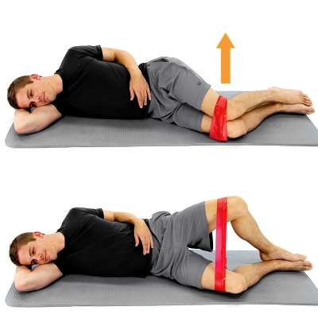 | While lying on your side with your knees bent and an elastic band wrapped around your knees, draw up the top knee while keeping contact of your feet together as shown.  Repeat 15 Times. Complete 2 Sets Perform 1-2 Times a Day
Ankle Dorsiflexion Self-Mobilization  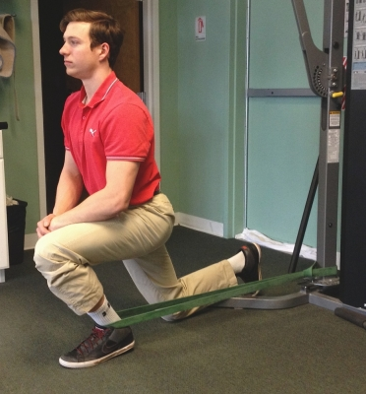 | Secure a band or belt around a stable object. Place one foot into the band and position yourself facing away from the object with the loop of the band in the front of the ankle crease. Get into a half-kneeling position and create tension in the band. With the foot placed firmly on the ground drive the knee forward out over the foot.  Repeat 10 Times Hold 10 Seconds Complete 3 Sets Perform 2 Times a Day
4 way Hip  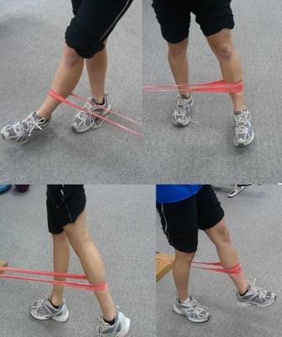 | Attach theraband to ankle and to a stationary object. Back up far enough to create tension on the band. You will do all 4 motions of the hip:  1. Hip Flexion - face away from the stationary object and bring leg forward. Keep good posture and leg straight. (Bottom right picture)  2. Hip Abduction - Stand sideways with involved leg away from stationary object. Lift leg directly outwards, using your outer thigh muscles (Top right picture)  3. Hip Extension - Stand facing stationary object and pull leg backwards away from your body using your glute muscles (Bottom left picture)  4. Hip Adduction - Stand sideways with involved leg on the side towards the stationary object. Stagger your feet slightly so the heel of involved leg is at the toes of uninvolved leg. pull involved leg across body in as straight of a line as possible (Top left picture)  Repeat 15 Times. Complete 2 Sets Perform 1-2 Times a Day
Tennis ball heel raises  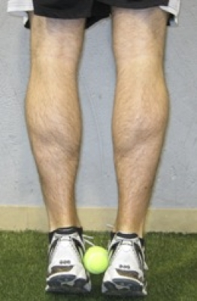 | Place a tennis ball between both heels and squeeze the ball. Raise up on your toes. Focus on even distribution of your weight on your feet and keeping the ball between the heels without dropping it.  Repeat 15 Times. Complete 2 Sets Perform 1-2 Times a Day
Side steps with band at toes  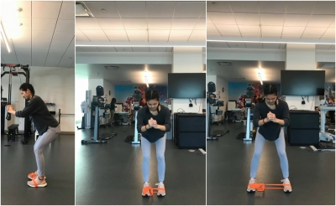 | With a TheraBand around the balls of your feet, get into a slight squat position (hips back) and perform side step, leaving a gap between the feet at all times. Make sure your toes are pointed straight forward the entire time.  Tip: Don't drag your feet and perform slow and controlled movements.  Repeat 15 Times. Complete 2 Sets Perform 1-2 Times a Day
Single leg stance  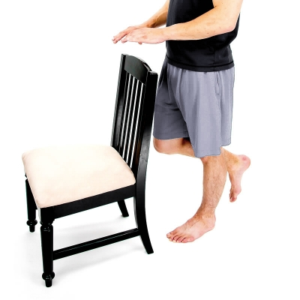 | Stand on one leg and maintain your balance.  Repeat 1 Time Hold 30 Seconds Complete 3 Sets Perform 1-2 Times a Day
Lateral Step Ups  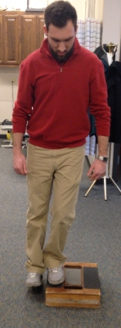 | Begin by standing with the involved leg on a step at your side with the knee and toes pointed forward. While maintaining upright posture, press through the heel to lift your other foot onto the step and return to starting position in a slow and control motion to touch your heel to the ground. Repeat.  Repeat 15 Times. Complete 2 Sets Perform 1-2 Times a Day

