IMG Physical Therapy

805 N. Richmond St., Suite 103 Fleetwood, PA 19522 610-944-8140

WWW.IMGPT.COM
Chris Gordos, DPT Andrea Miller, DPT
Eric Parrish, MPT Center Manager

Ankle Injury Home Exercise Sheet

Rehabilitation of the lower extremity may take an extended period of time. A loss of strength, range of motion, and use is common after an injury or surgery. You may also experience some swelling and popping noises. Your strength, range of motion, and use of the ankle can be regained. It may become frustrating at times, but you can be successful with hard work, patience, and listening to your body.

When you are exercising on your own at home there are some things to remember….

* Any specific exercise that causes pain, especially sharp knife like pain, is hindering the healing process for your injury and should be modified or discontinued until you notify your therapist.

* Increased swelling after exercise indicates that the exercise may be too difficult or it is not being done correctly. Be sure to ice that area of swelling and use a compression wrap as needed.

* Re-injuries during the rehabilitation process will slow your progress. If you
get recurring pain either lower the resistance; lower the number of sets or
repetitions; or reduce the range of motion to avoid the area of pain.

* You should experience muscle soreness, dull ache, fatigue, and stretching sensations, as long as
the exercises do not increase the pain or swelling.

* When in doubt about how much weight to use for exercises, guess low. It is
safer and easier to add weight than to hurt your self with too much weight.

* Consult your Physician or Physical Therapist if any problems arise or if you
have any questions regarding an exercise. It is better to make sure that you are
doing an exercise correctly than to cause further injury by doing an exercise
incorrectly.

These exercises are to be done 1 time per day or 3 to 5 days per week.
**Perform 2 sets of 15 repetitions for strengthening exercises**
**Stretch for 3-10 repetitions holding 10-30 seconds each time.**

Ice for 15 minutes after exercising and at the end of the day.

Ankle ABCs  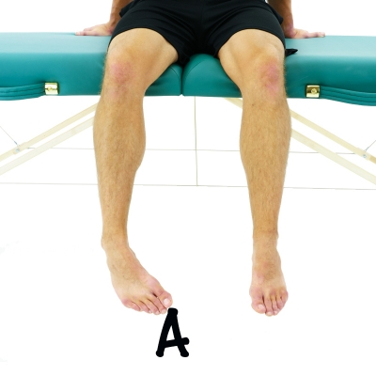 | While in a seated position, write out the alphabet in the air with your big toe.  Repeat 1 Time Hold 1 Second Complete 3 Sets Perform 2 Times a Day
Ankle Circles  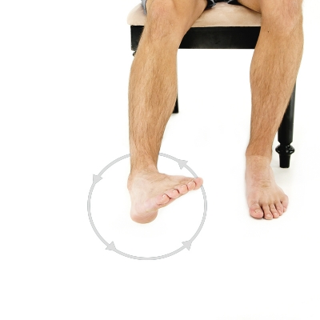 | Move your ankle in a circular pattern one direction for several repetitions and then reverse the direction.  Repeat 15 Times. Complete 2 Sets Perform 1-2 Times a Day
Towel Curls-Towel Scrunches  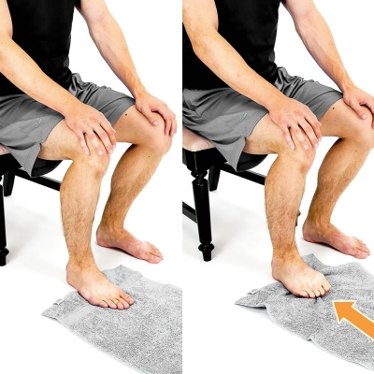 | While seated, use a towel and draw it back towards you using your toes. Curl your toes inward.  Repeat 15 Times. Complete 2 Sets Perform 1-2 Times a Day
Calf Stretch with Towel  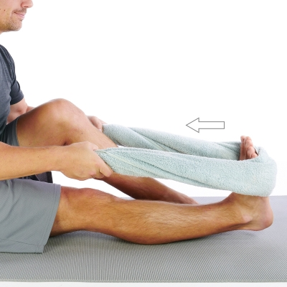 | While in a seated position, place a towel around the ball of your foot and pull your ankle back until a stretch is felt on your calf area.  Repeat 1 Time Hold 30 Seconds Complete 3 Sets Perform 2 Times a Day
Ankle 4 way with Theraband  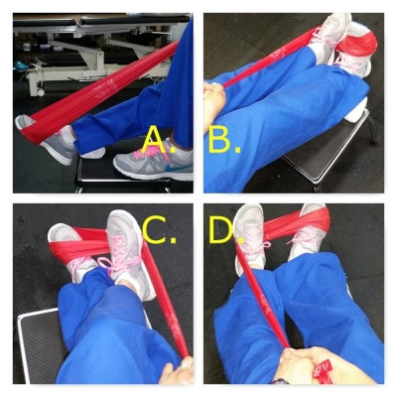 | A. Plantarflexion: "gas pedal." Keep knee straight. Band around "ball of foot" and press it away as far as possible and slowly return to neutral. Repeat.  B. Dorsiflexion: start in neutral and pull theraband back toward you as far as possible. pause. return slowly. keep knee straight.  C.Inversion: start neutral and bring band toward your midline  D. Eversion: start neutral and press band outward  Repeat 15 Times. Complete 2 Sets Perform 1-2 Times a Day
4 way Hip  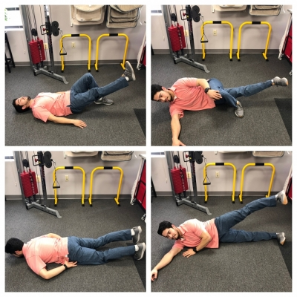 | Single Leg Raise: Begin on lying on your back, both legs bent towards your glutes. Straighten out the leg of focus, and lift until thighs match level. Lower with control. Repeat as prescribed.  ABDuction: Lying down on the side of the leg that is not being focused on (right leg is going to lift, laying on left side.) Have both legs straight with toes pulled up towards patient, and lift the top leg (leg of focus) up towards the ceiling. Lower back down with control. Repeat as prescribed.  ADDuction: Lying down on the same side of the leg that is being focused on - right leg is going to lift, laying on right side. Have both legs straight with toes pulled up towards patient, and cross the top leg over the bottom, and lift the bottom leg (leg of focus) up towards the ceiling. Lower back down with control. Repeat as prescribed.  Prone Extension: Laying down on your stomach, have both legs together and straight. Lift the leg of focus, driving the heel towards the ceiling as high as your can MAINTAINING A STRAIGHT POSITION. Lower the leg back to the start position. Repeat as prescribed.  Repeat 15 Times. Complete 2 Sets Perform 1-2 Times a Day
Heel raises  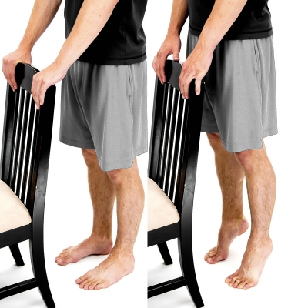 | While standing, raise up on your toes as you lift your heels off the ground  Repeat 15 Times. Complete 2 Sets Perform 1-2 Times a Day
Single leg stance  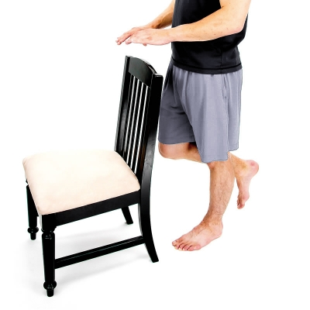 | Stand on one leg and maintain your balance.  Repeat 1 Time Hold 30 Seconds Complete 3 Sets Perform 1-2 Times a Day

