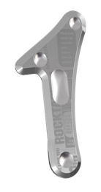
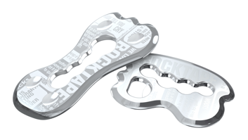
What are the “Blades”?

- They are metal tools that allow the therapist to apply a deeper and more effective massage to the soft tissues of your body
- Using these “blades” is also known as Instrument Assisted Soft Tissue Mobilization (IASTM)
- Soft tissues are muscles, ligaments, tendons, and fascia which are all made up of fibrous (tough) and elastic (stretchy) material
- The blades come in different shapes and sizes depending on the area of the body that is being worked on
How do they work?
- When you have injured the soft tissue in your body through repetitive use, excessive strain, or an actual tear of the tissue your body replaces the injured tissue with scar tissue
- Scar tissue is stiffer, has less blood flow, has reduced oxygen supply, and is more disorganized than the healthy tissue that was there before
- This scar tissue causes decreased flexibility (stiffness), decreased motion, and pain in and around the joints of your body
- The metal instruments (or “blades”) can help break up this scar tissue, increase blood supply, and bring in growth factors that help rebuild more healthy and organized tissue in the area
- All of this can help relieve your pain and increase your function

What areas of the body can they help?
- Any area of the body where there is soft tissue!
- Low back, neck, shoulders, feet, legs, and elbows are all very common places where IASTM can be beneficial

Why do we use Stopain® Gel with the blades?
- Provides a cooling effect (10% menthol base) and increases blood flow to the area
- The increased blood flow can help remove waste products from the soft tissue and bring new growth factors
- Helps relieve pain and relaxes muscles

