
IMG PHYSICAL THERAPY 805 N RICHMOND STREET, SUITE 103, FLEETWOOD, PA 19522 PHONE: 610-944-8140 FAX: 610-944-8190 IMGPT.COM CHRIS GORDOS, DPT ERIC PARRISH, MPT ANDREA MILLER, DPT

Thinking about trying CBD oil for pain relief?

Chronic pain is the most common reason for medicinal cannabis use, according to a recent survey.
﻿If you have a chronic pain condition and have not been able to manage it with standard treatment (or are looking to avoid the potential adverse effects of other medications), you may be considering CBD oil for pain relief. Although CBD oil comes from the marijuana plant, it is not marijuana and will not produce a “high” feeling. So far, animal research suggests that CBD may have moderate pain-relieving effects for neuropathic pain without the cannabinoid-like side effects; however, there is currently a lack of large, well-designed clinical trials on humans (the type of research you want to see to put your full confidence in a treatment) confirming these effects.
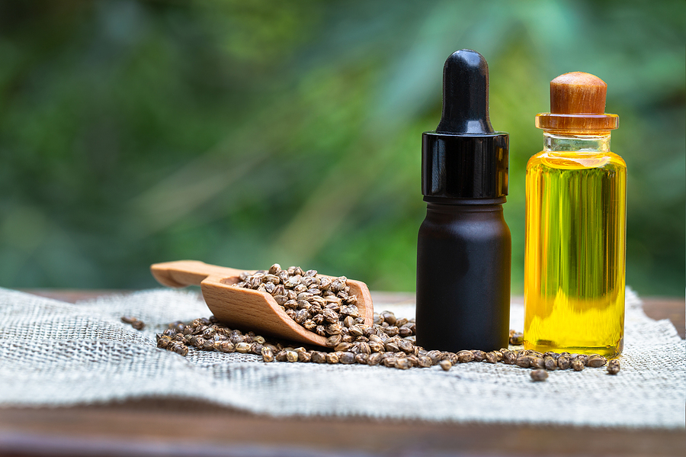
If you're thinking of trying CBD oil for pain relief and it is legal where you live (it is in PA), talk to your doctor to discuss whether it's appropriate for you and the safest way to incorporate it into your pain management plan. Per our practice act, we as physical therapists, are not allowed to recommend its use. Please keep in mind that due to the lack of regulation, the purity and content of CBD oil products can vary.

