What is the job of our Vestibular System?

Central Vestibular Disorders
  - Disclaimer: The information provided in this brochure is for educational purposes only and does not replace the advice and direction from a medical professional. ALWAYS consult your physician or vestibular rehab specialist Eric Parrish, Andrea Miller, and Morgan Shade at IMG PT before beginning any of the exercises to ensure the safety of all individuals. Contact IMG Physical Therapy at (610)-944-8140 to get a free consult or examination today.

The vestibular system is a sensory system in our body that helps to regulate head and body position in space, coordinate eye and head movements, and maintain balance and postural stability. Three systems work together to help us maintain our balance including the visual system, the somatosensory system, and THE VESTIBULAR SYSTEM. When there is injury or insult to the vestibular system it can greatly impact daily activities such as getting in/out bed, driving, standing, walking, and recreational hobbies.  What is Vestibular Rehabilitation Therapy?  By implementing certain exercises that focus on coordinating eye, head and body movements, we can begin to retrain the vestibular system and promote compensations through use of visual and somatosensory systems to reduce impairments including postural instability and falls, gait deviation, vertigo/dizziness.  Gaze Stability Exercises  - Use small playing card arm’s length away  - Perform gaze stability exercises 2-3x/day for a total of 20-40 mins  - https://www.vestibular.today/vestibular-rehab-exercises Great resource for videos  VOR x1: Focus eyes on target, target remains still, head moves while keeping eyes fixated on target  VOR x 2: Maintain eyes on target, now head and target move in opposite directions while eyes remain fixated on target  Two Target VOR: One target in each hand, move eyes toward target A then move head toward A, move eyes toward target B, then move head toward B (eye movements lead head movement)  Remembered Targets: Look at target on wall, close eyes and move head in any direction, keeping eyes on target, open to see if gaze is held. Repeat all directions |  | 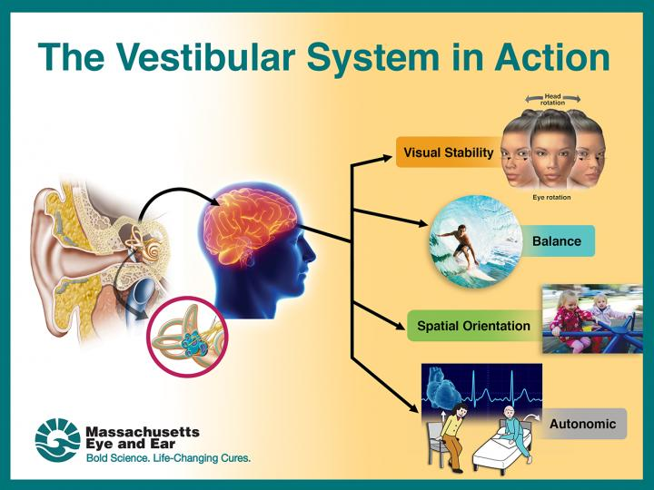
Remembered Target Exercise
Two Target VOR |  |  | VOR x 1 – Target still
VOR x 1 – Head still |  |  | VOR x 2  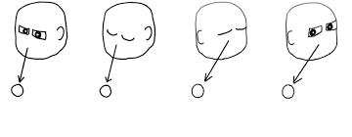
- Transfer sit to stand exercise: Begin in sitting position and rise from chair without using hands, perform 1-2 sets of 15 reps

Balance and Gait Exercises
- Perform balance and gait exercises 1-2x/day 3-5 days per week
- CAUTION: for all balance exercises use chair/counter for support or perform near corner of wall

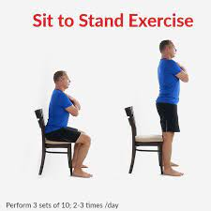

- Balance with feet together, tandem stance, single leg stance: holding each position 20-30 seconds for 3 reps each
- Vary the above exercises with eyes open and eyes closed

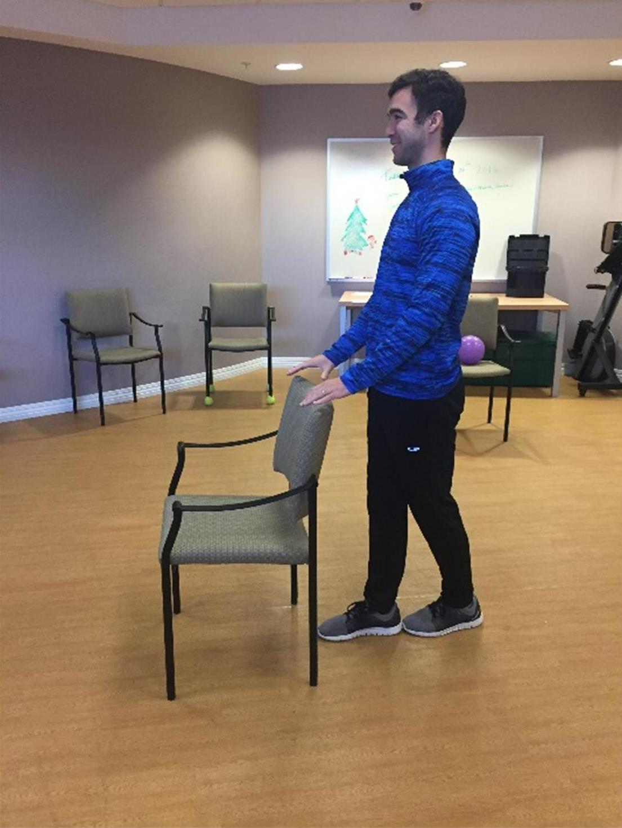
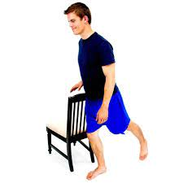

4. Standing marches: Upper extremities supported on stable surface begin to march in place, 1-2 sets of 15 reps

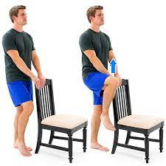

- Ankle, hip, stepping strategy exercise: 10x/each direction
- Ankle strategy: begin with small sways forward and backward, emphasize movement at the ankle and minimize movement at the hip/trunk/arms
- Hip strategy: Patient will sway fwd/bkwd past limits used with ankle strategy now using hips and arms to maintain balance
- Stepping strategy: Move body fwd and bkwd and side to side until you feel like you are about to lose your balance, then take a large step to regain balance

- Weight Shifts: Standing with one foot in front of the other and begin shifting 50-75% of weight onto front foot and then to back foot, repeated exercise with lateral weight shift, 3 min shifts each way

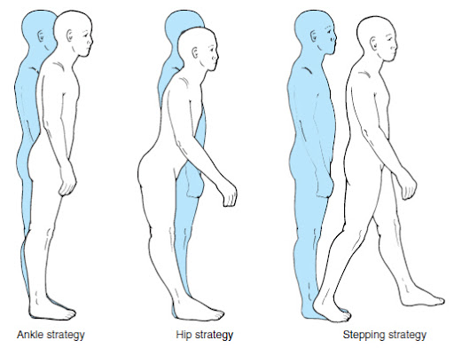
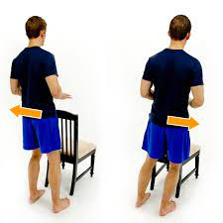
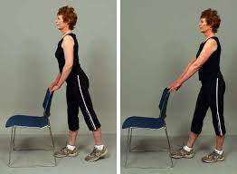

Habituation Exercises:
These exercises are performed in order to reduce symptoms in response to provoking movements
- Perform these exercises 1-2x/day

- Diagonal Head motion: Begin in sitting position with feet on floor, bring head down to opposite knee, hold position until symptoms resolve plus 30 seconds. Repeat opposite side.

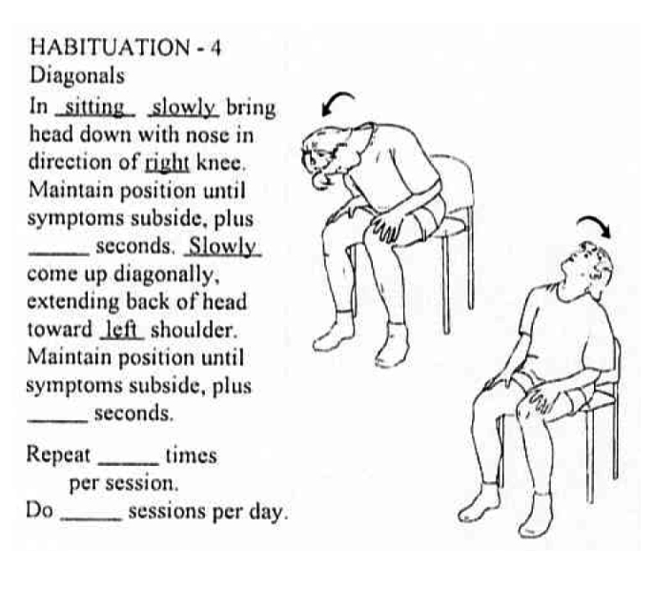
- Perform head movements in horizontal/vertical and circular motions: Turn slowly one direction, if symptoms come on wait until they stop plus 30 seconds, repeated in all other opposite directions.

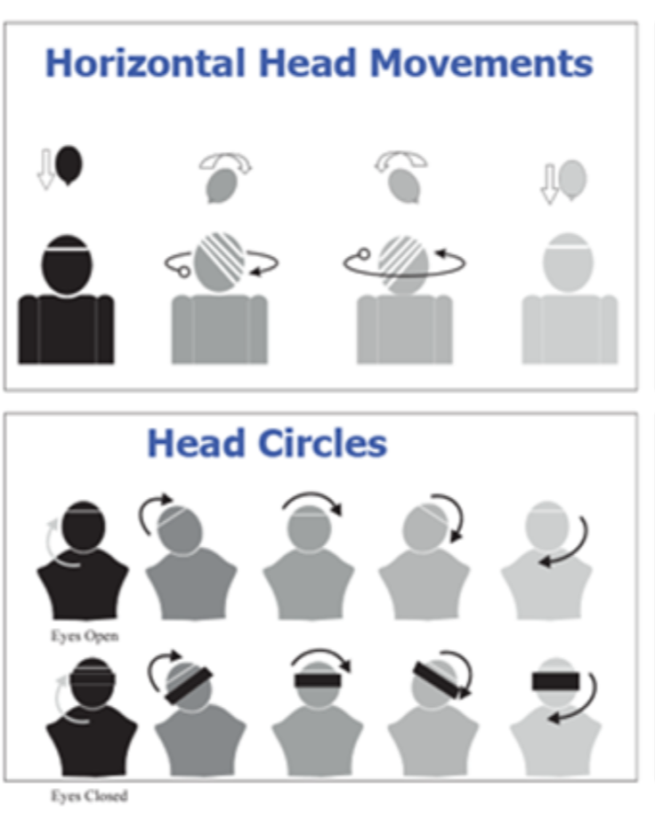

3. Head rotation with trunk turns: Alternating turning head and trunk to the left and then to the right. If symptoms come on, wait until they cease plus 30-60 secs. Repeat 10x.

