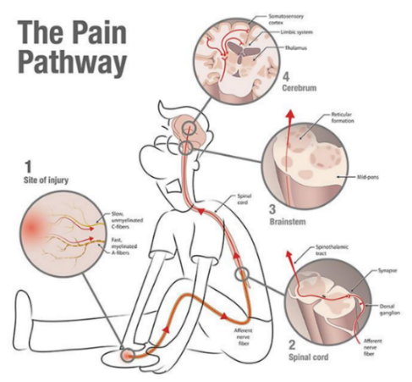
After an injury, the pain you feel is initially beneficial because it alerts you when a part of your body needs to be temporarily protected. However, with chronic pain, the pain you feel is not a good indicator of actual damage. When you’ve had pain for months or years, the connections between the cells in your brain can get stronger. Your brain can get better at processing pain, even if the body itself has healed.
Chronic Pain & Your Brain
Similar to how you can learn a new language or develop the skill of riding a bike, the longer you “practice” feeling pain, the more your brain “learns” to feel pain.
All pain is felt in the brain: Even if it is your knee or back that hurts, or if imaging showed “damage” in that body part, it is still your brain that decides & then informs you that those joints hurt. Pain is essentially an emotion.

Think of your pain as a sound & your brain as a microphone

- When you experience a new pain, the microphone is off, so you hear the sound at the exact volume that it happened at.
- With chronic pain, the microphone (your brain) is on and more sensitive. When that same sound happens, you hear the sound (the pain) at a much louder volume and it’s much harder to ignore!

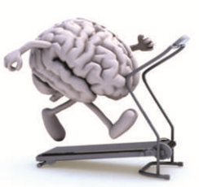
Our current emotions and thoughts can affect the intensity of the pain we feel: Have you ever noticed that if you’re having a REALLY rough day and you stub your toe, it seems to hurt really bad? But if you are having a great time hanging out with friends and you stub your toe, it doesn’t hurt as bad and it’s easier to laugh it off? This is because the areas of the brain that help calm down pain are more active. Also, expecting something to hurt (such as bending over or walking upstairs) can activate some of the same brain areas that activate when you actually feel pain, making that pain feel worse.

What can we do about it?
The good thing is, all of these brain changes are reversible.
- Find a form of exercise that you enjoy. If your physical therapist has you doing exercises that you fear because it’s been painful in the past, tell them! There are lots of different ways to gradually improve your function & strengthen muscles; we can find a way that works for you. The brain especially likes aerobic exercise, so gradually incorporating more movement into your day & getting your heart rate up can help decrease your pain levels and even improve your emotions.
- Find healthy foods that you enjoy. Eating “anti-inflammatory” foods, such as blueberries and spinach, may help decrease pain and also positively affect your mood. But don’t feel like you need to miss out on other foods you enjoy by overly restricting your diet, especially during social events, since socialization is also beneficial for your brain.
- Find relaxation techniques that you enjoy, or consider seeing a mental health therapist. By finding ways to relieve stress and reframe your thinking w/ meditation, deep breathing, or therapy, you can train the cells in your brain to undo the unhelpful changes that lead to the increased pain in the first place.
It’s all about balance! With chronic pain, it’s easy to get caught up and spend so much time, money, & energy trying to get rid of the pain that it takes away from other aspects of life that you enjoy, which can lead to frustration and an “all-or-nothing” mindset. By taking care of your brain and body together, you can help address your pain while also improving your overall quality of life.

