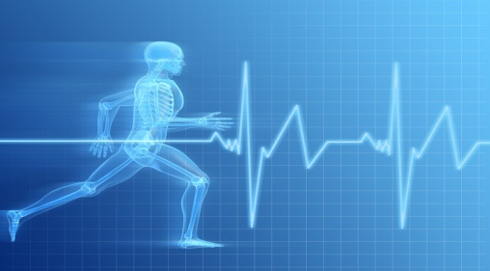
IMG PHYSICAL THERAPY 805 N RICHMOND STREET, SUITE 103, FLEETWOOD, PA 19522 PHONE: 610-944-8140 FAX: 610-944-8190 IMGPT.COM CHRIS GORDOS, DPT ERIC PARRISH, MPT ANDREA MILLER, DPT
IMPORTANCE OF CORE STRENGTH (Step 1: Beginner Program)

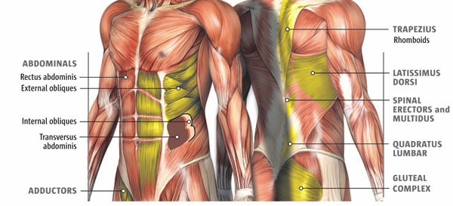
What is your core?
- Front muscles: internal & external obliques, transversus abdominis, rectus abdominis
- Back muscles: erector spinae, latissimus dorsi, multifidi, quadratus lumborum, gluteals

Core strength at work
- Physically-demanding jobs (firefighters, construction workers, military, personal trainers, postal service, landscapers), as well as desk jobs, require strength stemming from the core in order to prevent injury and maintain good posture.

Core strength in sports
- Almost all sports require good control of trunk motion in order to maximize performance and reduce risk of injury.

Core strength in daily life
- A forward head & rounded shoulders posture is common in all populations, especially older adults.
- Older adults also have a higher rate of impaired balance.
- A stronger core helps to prevent injury to postural muscles, as well as to reduce risk of falling.
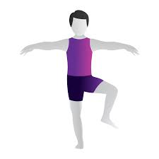
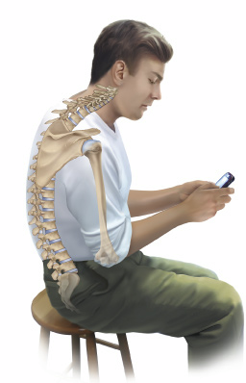
Simple Core Strengthening Exercises

Glute set Posterior pelvic tilt
*squeeze butt cheeks together *tighten stomach & press lower back into floor/table
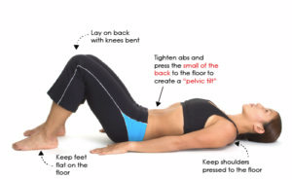
*10 sec. hold x 10 *10 sec. hold x 10
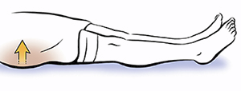

Seated stability Slump correct
*lift opposite arm & leg into air *from a slumped forward posture,
(like marching in place) push shoulders and head back to
* x15 each side sit up straight & tall
*start out in chair, then progress to exercise ball * x20-30
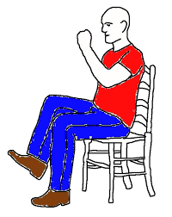
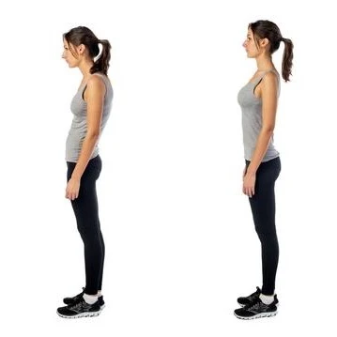

***For any questions or issues with your back or core, feel free to contact the experts at IMGPT!***

