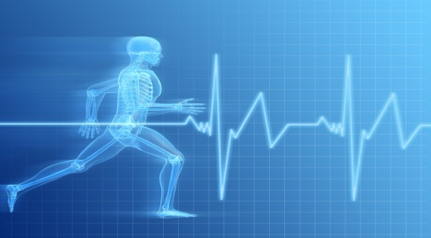
IMG PHYSICAL THERAPY 805 N RICHMOND STREET, SUITE 103, FLEETWOOD, PA 19522 PHONE: 610-944-8140 FAX: 610-944-8190 IMGPT.COM CHRIS GORDOS, DPT ERIC PARRISH, MPT ANDREA MILLER, DPT
IMPORTANCE OF CORE STRENGTH (Step 2: Advanced Program)

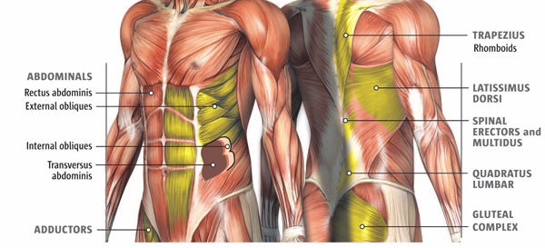
What is your core?
- Front muscles: internal & external obliques, transversus abdominis, rectus abdominis
- Back muscles: erector spinae, latissimus dorsi, multifidi, quadratus lumborum, gluteals

Core strength at work
- Physically-demanding jobs (firefighters, construction workers, military, personal trainers, postal service, landscapers), as well as desk jobs, require strength stemming from the core in order to prevent injury and maintain good posture.

Core strength in sports
- Almost all sports require good control of trunk motion in order to maximize performance and reduce risk of injury.

Core strength in daily life
- A forward head & rounded shoulders posture is common in all populations, especially older adults.
- Older adults also have a higher rate of impaired balance.
- A stronger core helps to prevent injury to postural muscles, as well as to reduce risk of falling.
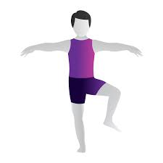
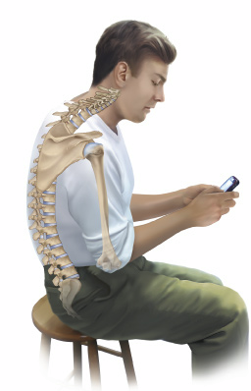
More Difficult Core Strengthening Exercises
***These exercises are more challenging and should not be attempted by everyone***

Plank / side plank High bird-dog
*start with 2x30 sec. hold, then increase *2x15 each side
as needed *from all fours, raise opposite arm & leg
*keep a straight line from shoulders to into air, keeping body level
hips to ankles *hold 5 sec. then switch sides

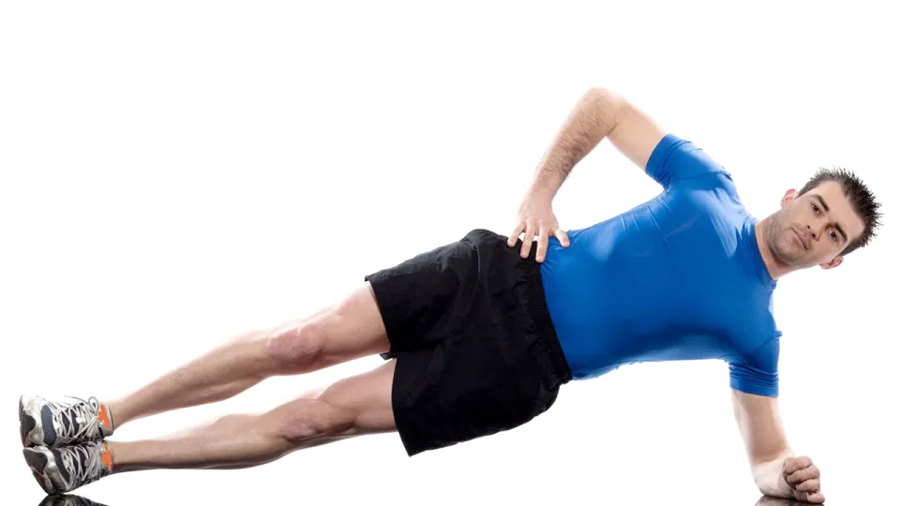
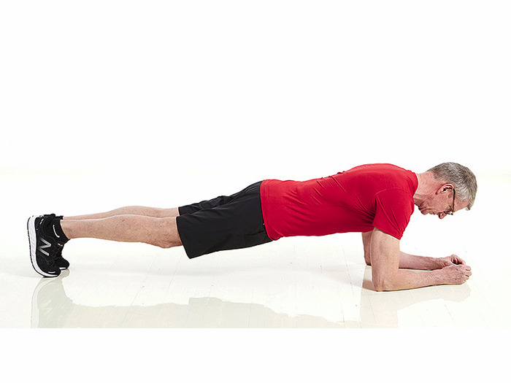
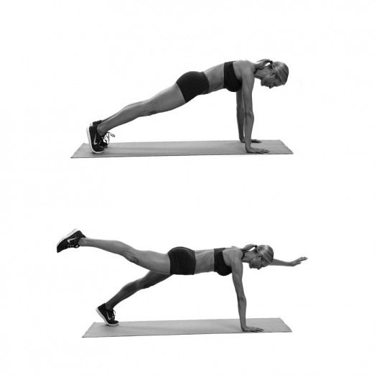

Single-leg glute bridge Single-leg balance with dumbbell press
*raise one leg in the air, then push *start on one leg with weight in opposite
hips/pelvis up into air, hold 5 sec. hand, then press arm up overhead
*2x15 each leg *2x15 each side
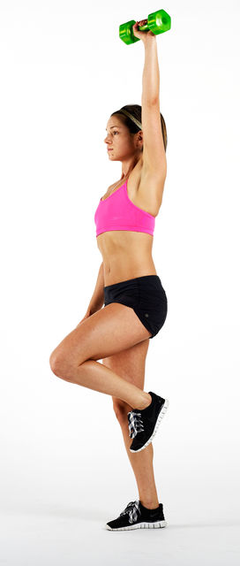
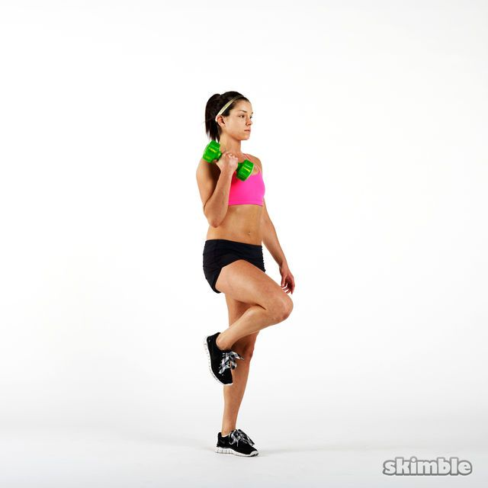
*add weight to abdominal area for
more challenge
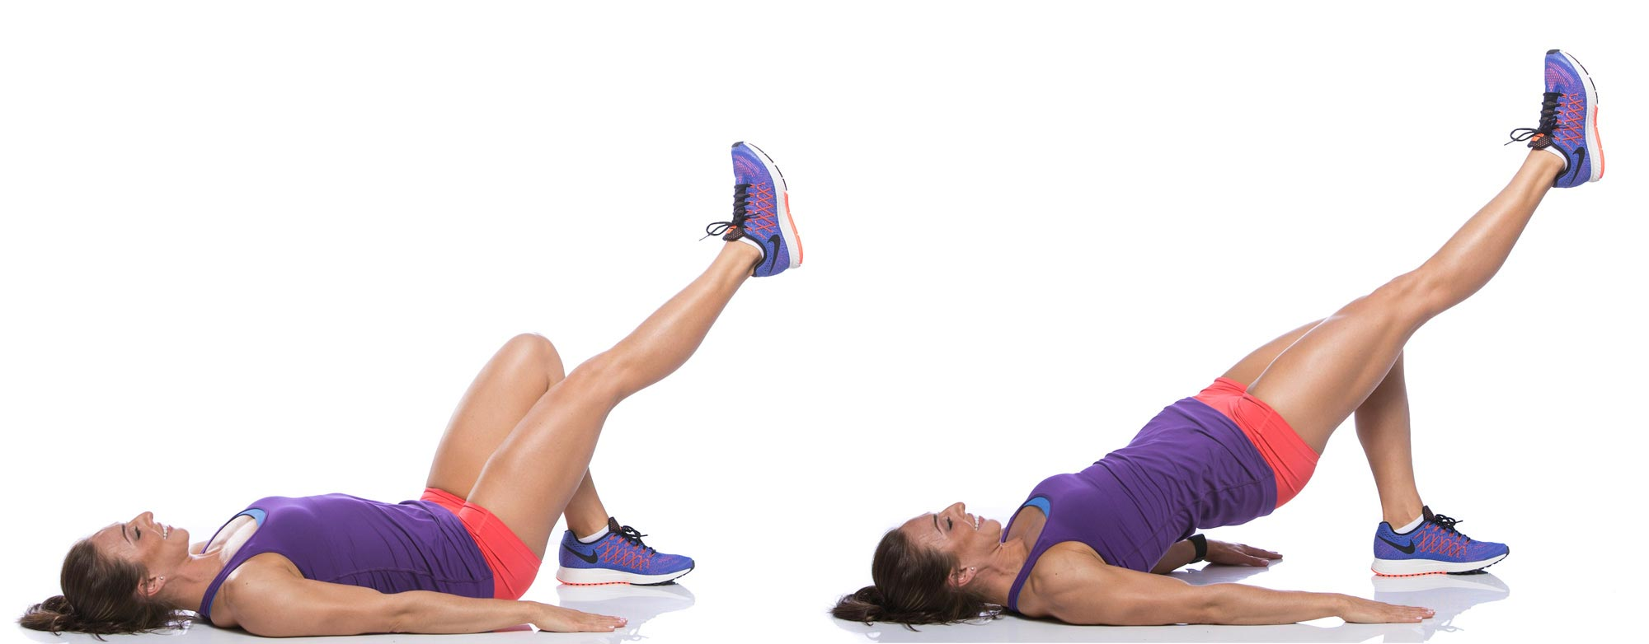

***For any questions or issues with your back or core, feel free to contact the experts at IMGPT!***

