IMG PHYSICAL THERAPY
805 N. Richmond St., Suite 103 Fleetwood, PA 19522 610-944-8140
WWW.IMGPT.COM
Chris Gordos, DPT Andrea Miller, DPT
Eric Parrish, MPT Center Manager

DECONDITIONING EXERCISES

Rehabilitation for Deconditioning can take a long time. A loss of strength is common after an injury or surgery; however, the strength and range of motion can be regained. It may become frustrating at times but you can be successful with hard work and a lot of determination.

When you are exercising on your own there are some things to remember….

◊ Any specific exercise that causes pain is hindering the healing process
for your injury and should be modified or discontinued.

◊ Re-injuries during the rehabilitation process will slow your progress. If you
get recurring pain either lower the resistance; lower the number of sets or
repetitions; or reduce the range of motion to avoid the area of pain.

◊ Most exercises that do not involve the injured region can be done as long as the exercise does not increase the pain.

◊ When in doubt about how much weight to use for exercises, guess low. It is
safer and easier to add weight than to hurt your self with too much weight.

◊ Consult your Physician or Physical Therapist if any problems arise or if you
have any questions regarding an exercise. It is better to make sure that you are doing an exercise correctly than to cause further injury by doing an exercise incorrectly.

These exercises are to be done 3 to 5 days per week.
If you are feeling pain, Ice / Moist Heat for 15 minutes after exercising to assist with pain reduction.

Part 1: Beginner
Exercise | Image | Description
Diaphragmatic Breathing  Start with 10 deep breaths when you wake up. Progress by adding this form of breathing throughout your day during other activities or exercises. | 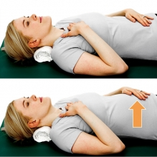 | While lying down, place one hand on your chest and one hand over your belly button. Slowly take a deep breath in and focus on trying to get your hand on your stomach rise while the hand on your chest remains still.
Ankle Pumps  2 sets of 15  2-5x per day | 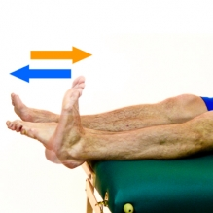 | Bend your foot up and down as if you were pushing and releasing from a gas pedal.  This exercise is also great for circulation in your legs!
Quad set  10 sec. Holds 10 times  2x per day | 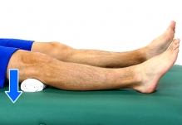 | Tighten your thigh muscle as you push the back of your knee downward into the bed or a towel.
Transverse Abdominis Activation  10sec holds 10x  2x per day | 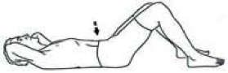 | Pull your belly button in towards your spine, flattening your back onto the table. Hold this position while continuing to breathe.
Supine XY  2 sets of 15  2x per day | 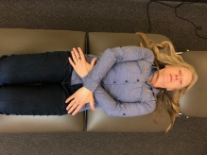  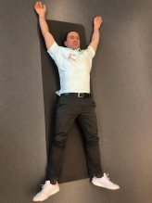 | Start on your back with your arms crossed, forming an “X” with your hands resting on your pelvis. Next lift arms up and out, forming a “Y” as if you were doing the YMCA dance. Next lower hands to “X” position and repeat steps.

Part 2: Intermediate
Exercise | Image | Description
Seated Marches  30 sec with 10 sec breaks, start with 2 minutes of marching, add 30 seconds when you feel the exercise is getting easier. | 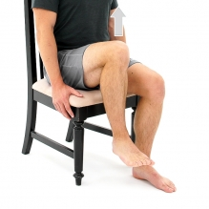 | While seated in a chair, lift foot and knee off the ground and gently place limb back down. Repeat with the opposite leg, continue to alternate your legs.
Bridging  2 sets of 15  2x a day | 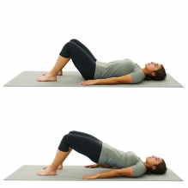 | Start on your back with your knees bent. Tighten your tummy and buttocks, while pushing through your legs lift your buttocks up off the table. Slowly lower buttocks back down towards the table. Relax and repeat, remembering to breathe.
Sit to stand from a chair and/or elevated surface  Complete however many reps until you start to “feel the burn,” then complete 2 more reps. Use this number as a target, and slow increase reps as you feel the exercise becomes easier. | 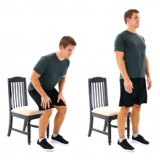 | Patients can elevate the surface with the use of blankets or pillows if they need to modify exercise to be easier.  Patient starts by sitting towards the edge of the chair, leaning weight forward to get their nose over their toes, and then finally push up through their legs and hands on their thighs if needed. Important to control the descend sitting back into the chair to avoid “flopping.”
Single Leg Balance with or without support  3 sets of 30sec holds on each side.  1x per day | 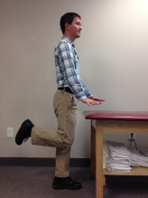 | Start by standing close to a sturdy table, countertop, or heavy chair. Raise one leg slightly off the ground. If possible, allow your hands to let go of the sturdy surface and just hover above the surface in case you need to grab on for support. Hold leg off the ground for 10-30 seconds and then lower leg. Repeat 3-5 times on each leg, alternating legs.

Part 3: Advanced
Exercise | Image | Description
Weighted squat chop  Complete however many reps until you start to “feel the burn,” then complete 2 more reps. Use this number as a target, and slow increase reps as you feel the exercise becomes easier. Instead of increases the number of reps when the exercise gets easier, you can increase the weight you are holding. | 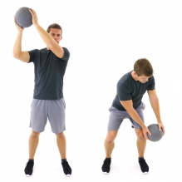 | Start with weighted object (medicine ball, dumbbell, can of soup, bag of rice, etc.) down at your side while in a squat position. Next stand up as you lift object to the opposite shoulder. Drop down into squat position, lowering object to starting side. Repeat exercise on each side
Walking |  | The Physical Activity Guidelines for Americas recommend 150 minutes of moderate walking per week. This total amount of minutes is an end goal target, so start with a target weekly time that is more fitting for you. Your weekly goal can be broken down into 10-30 min walks spread throughout the week. Start with three 10 min walks in your first week, walking at a brisk pace to ensure you are getting your heart pumping. Assess how you felt after week one and decide if the number of walks and time spent walking felt like a challenge or if it was too easy. From there keep the time the same if it was a challenge or add an addition 5 minutes to each walk. Continue this process until you reach or exceed 150 minutes of vigorous walking per week.
Exercise Classes such as but not limited to Ti Chi, Yoga, Pilates, Boxing | 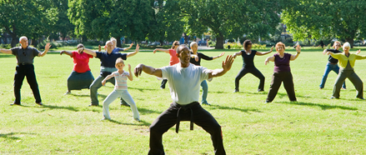 | Talk to your PCP or reach out to local community centers/gyms to see what exercise classes are being offered in the future.

