IMG PHYSICAL THERAPY
805 N. Richmond St., Suite 103 Fleetwood, PA 19522 610-944-8140
WWW.IMGPT.COM
Chris Gordos, DPT
Eric Parrish, MPT, Center Manager and Vertigo Specialist
Andrea Miller, DPT Balance and Falls Specialist

Glute Strengthening for Runners
Running involves many muscles in the body, especially the core and leg muscles. The gluteus maximus and medius are two muscles that have multiple functions while running. They contribute to postural control to keep the pelvis level, knee alignment, and propelling us forward. Without adequate glute strength, there is a potential for overstriding, knees caving in, and legs crossing midline. This can further lead to injuries at the knee, hip, back, etc.
When you are exercising on your own there are some things to remember….

◊ Any specific exercise that causes pain is hindering the healing process
for your injury and should be modified or discontinued.

◊ Re-injuries during the rehabilitation process will slow your progress. If you
get recurring pain either lower the resistance; lower the number of sets or
repetitions; or reduce the range of motion to avoid the area of pain.

◊ Most exercises that do not involve the injured region can be done as long as the exercise does not increase the pain.

◊ When in doubt about how much weight to use for exercises, guess low. It is
safer and easier to add weight than to hurt yourself with too much weight.

◊ Consult your Physician or Physical Therapist if any problems arise or if you
have any questions regarding an exercise. It is better to make sure that you are
doing an exercise correctly than to cause further injury by doing an exercise
incorrectly.

Choose 3-5 exercises to complete 3 days a week. Mix up the exercises each time.
Perform 2 sets of 15 repetitions for strengthening exercises
Stretch 3-15 times, holding 10-30 seconds each time.

Moist Heat for 15 minutes before / after exercising. If using Ice, 15 minutes after exercise.
Sidelying Hip Progression
1.Clam Shell
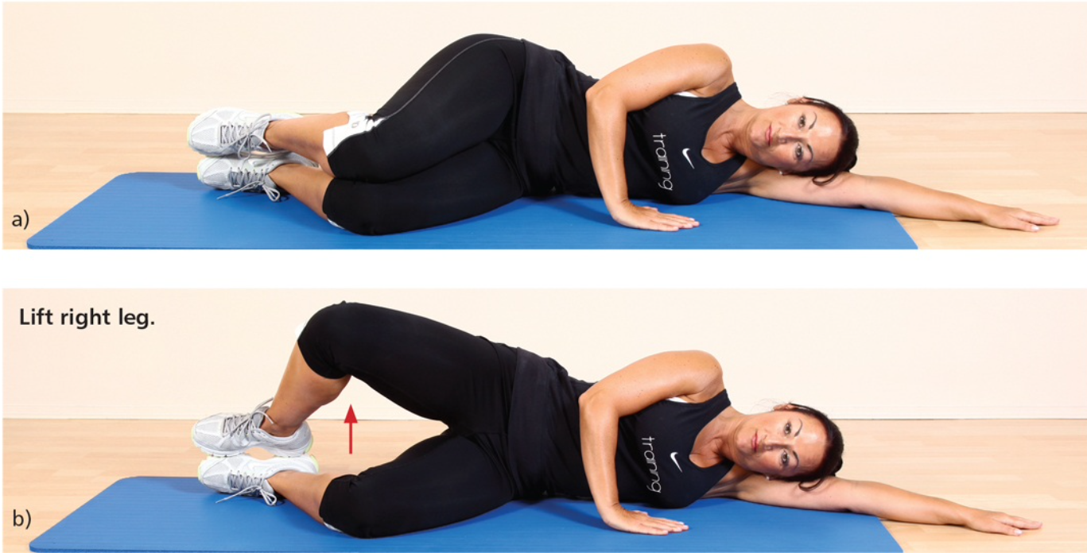
Lie on one side with knees bent, lift top knee off the other keeping feet together. Complete 2-3 sets of 12-15 reps each side. Use band around knees to progress

2. Side-lying Hip Abduction
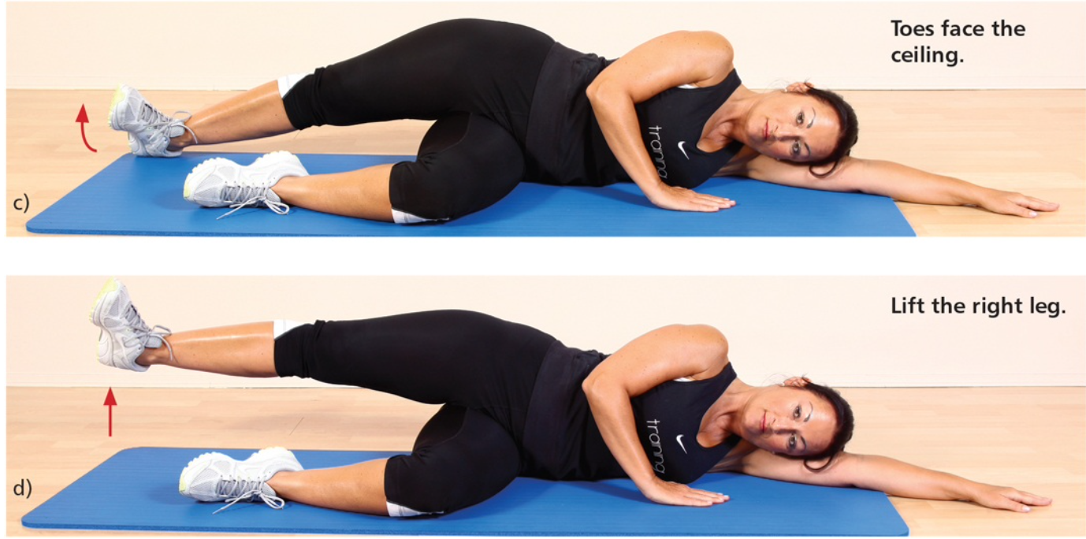
Lie on one side with bottom leg bent and top leg straight. Turn toes of top leg toward the ceiling and lift leg up towards ceiling in hip extension. Complete 2-3 sets of 12-15 reps each side.

3. Side Plank with Hip Abduction
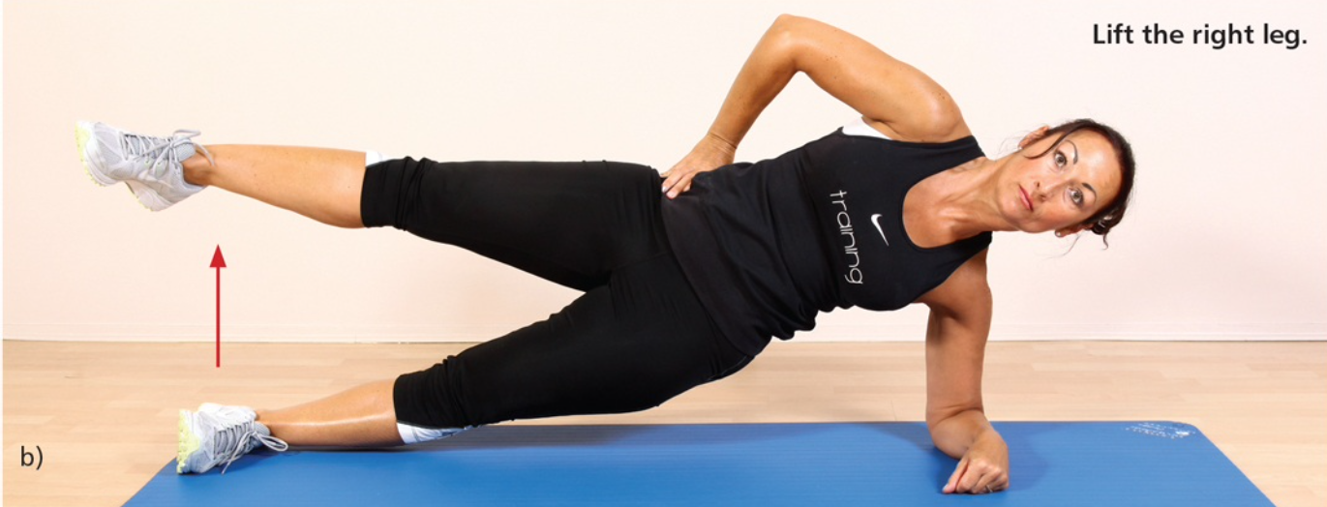
Begin in a side plank with shoulders, hips, knees, and ankles in line. Raise top leg towards the ceiling. Complete 2-3 sets of 12-15 reps on each side.

Bridge Progression
1. Bridge
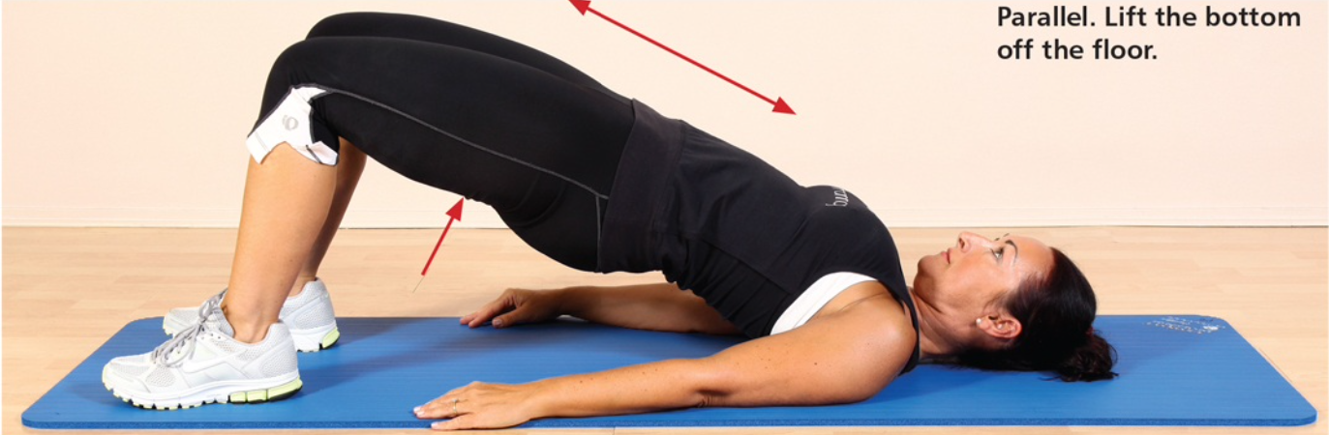
Lie on floor with knees bent. Lift bottom up off floor and lower back down. Complete 2-3 sets of 12-15 reps on each side.

2. Frog Bridge
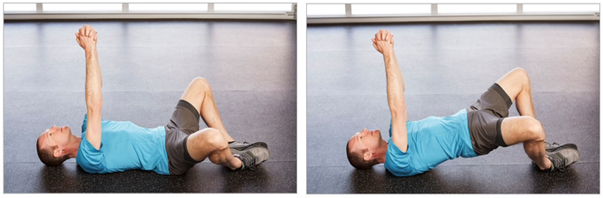
Lie on back with knees bent and apart and feet together. Lift bottom up off floor. Repeat for 2-3 sets of 12-15 reps each side.

3. Single Leg Bridge
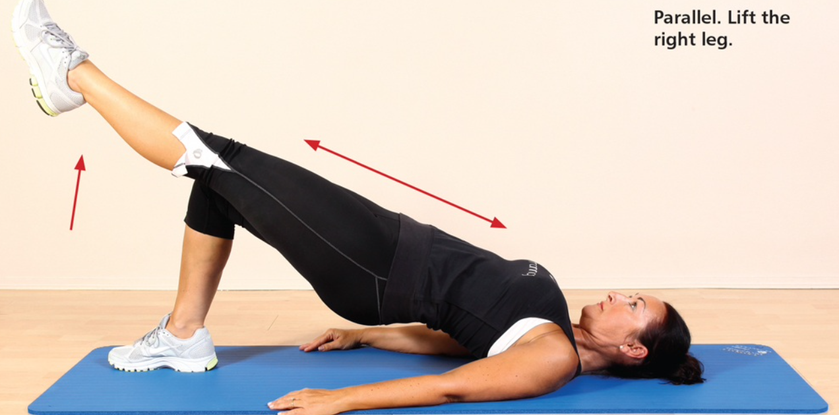
Lie on floor with knees bent. Straighten one leg and hold in line with opposite thigh. Lift bottom up off floor with leg/foot still on surface. Complete 2-3 sets of 12-15 reps on each side.

4. Hip Thrust
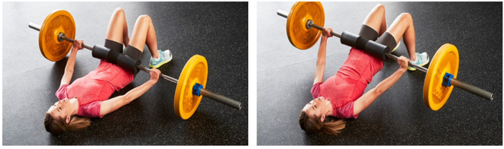
Position with Olympic bar across hips with bar pad as cushion. With knees bent, push hips and bar up. Goal is 2 times body weight. Complete 3 sets of 6 reps.

Squat Progression
1. Goblet Squat
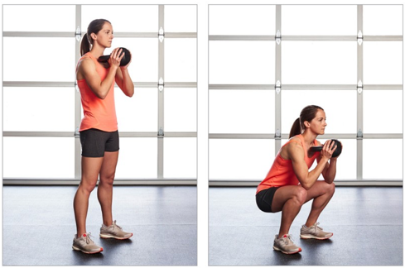
Hold a dumbbell or kettlebell at chest height and have feet slightly more than shoulder width apart. Squat down until elbows touch your thigh and return to standing. Complete 2-3 sets of 10-12 reps.

2. Kettlebell Swing
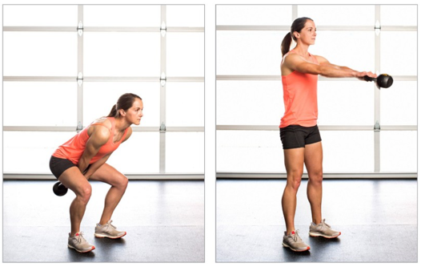
Stand with feet shoulder width apart. Hold kettlebell in both hands, arms straight. Push hips back like squatting and explode hips forward to get weight to shoulder height. Complete 3 sets of 8 reps.

3. Lunge
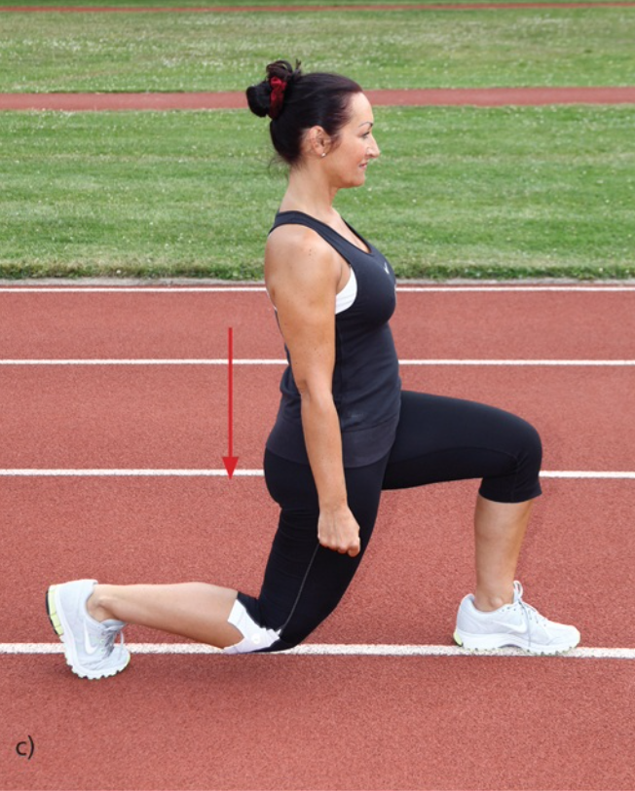
Stand with feet shoulder width apart and step forward with one leg and bend front leg to 90 degrees allowing back knee to bend. Repeat 2-3 sets of 12 reps each leg. Add dumbbells in each hand for progression.

4. Bulgarian Split Squat
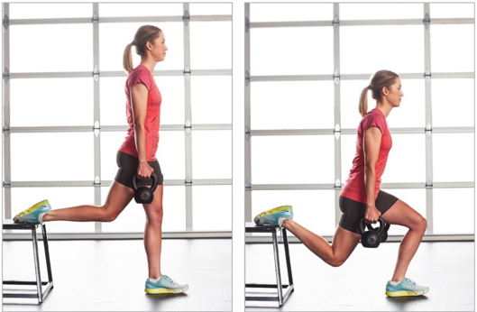
Put one foot behind you on bench in staggered stance. Keep trunk upright as you lower into a squat on front leg. Complete 2-3 sets of 8-10 reps. Add weight in each hand to progress.

5. Single Leg Squat
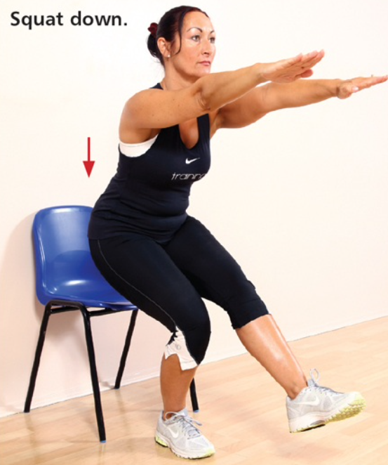
With chair behind, stand on one leg and squat down until you feel the chair and stand back up. Complete 2-3 sets of 10-12 reps each leg. Progress by removing the chair for a deeper squat.

6. Back Squat
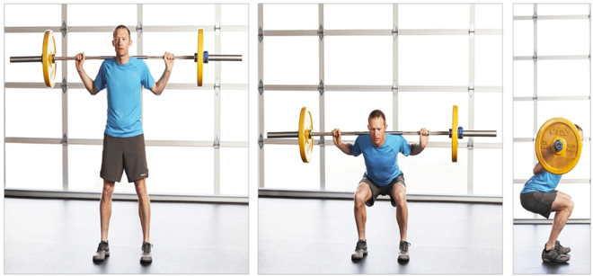
At squat rack, set up bar at shoulder height. Position under the bar so bar is across traps and above shoulder blades. Grip bar with hands. Stand up under bar and take a few steps back. Keep feet shoulder width apart, sink hips back into a squat parallel to floor. Drive heels through floor to standing. Complete 3 sets of 6 reps. Goal weight is 1.5 times body weight for 6 reps.

Deadlift Progression
1. Kneeling Banded Deadlift
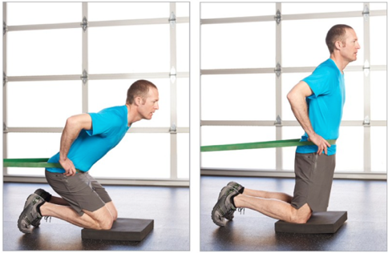
Attach Powerband to rack and kneel inside band facing away from it. Kneel with band around waist far enough away to feel tension pulling hips back. Sink hips into heels and push hips forward keeping back straight. Complete 2-3 sets of 15 reps.

2. Single Leg Deadlift
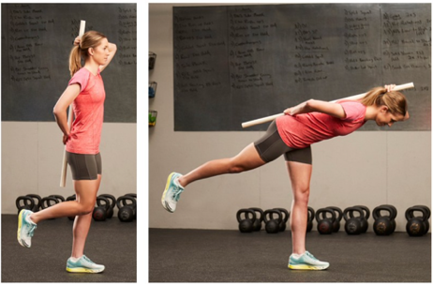
This can be done without dowel on back.
Stand on one leg with slight bend in knee and bend forward keep spine neutral. Push hips forward to return to standing. Complete 2-3 sets of 12-15 reps each leg.

3. Romanian Deadlift
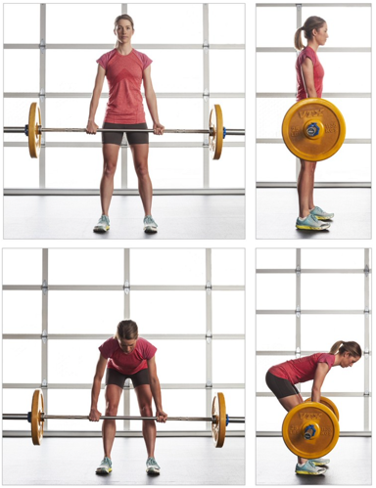
Stand with feet shoulder width apart and Olympic bar over tie of shoelaces. With slight bend in knees, bend and squat down to hold bar with a mixed or alternating grip. Drive heels into the ground to drive hips forward and pull bar into standing position. Push hips back and lower towards floor. Complete 3 sets of 8 reps. Goal weight is 1.5-1.8 times body weight.

Step-up Progression
1. Forward Step-up
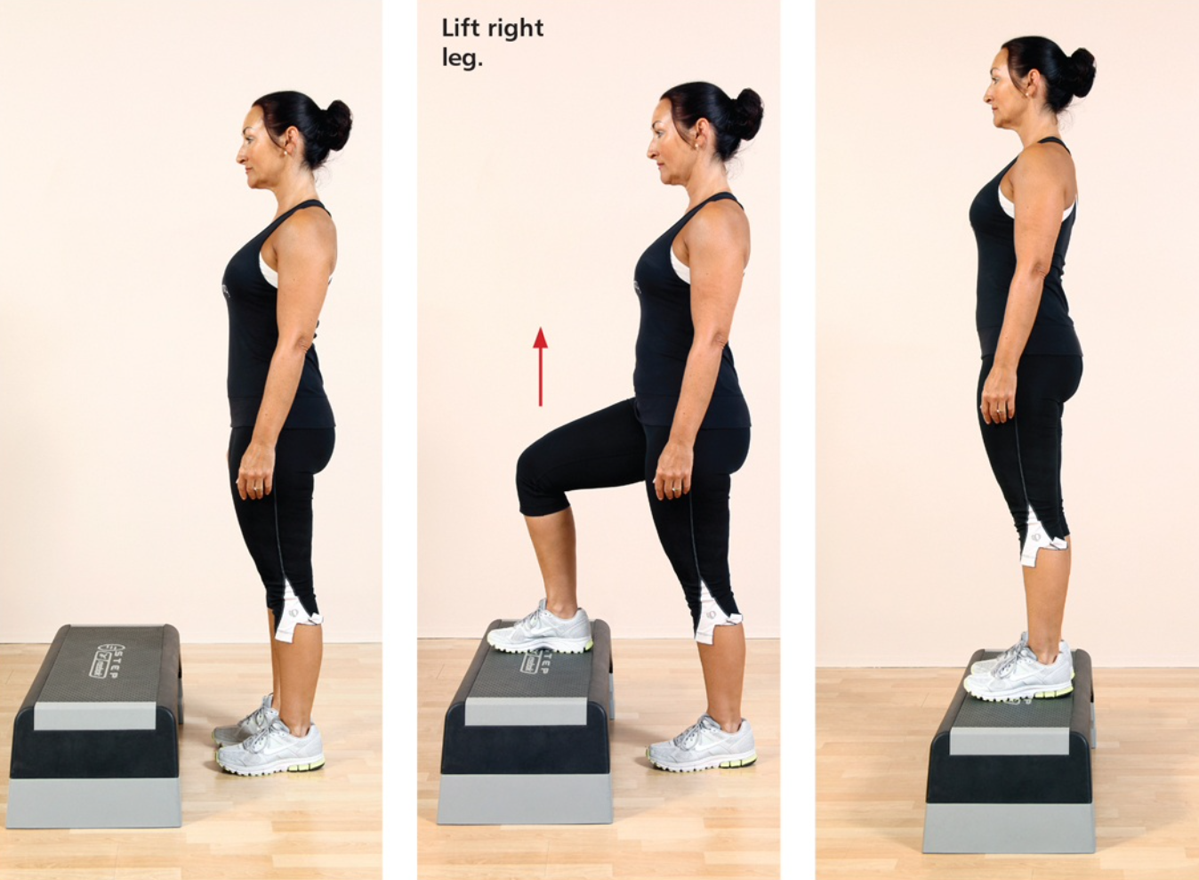
Face a step or box. Step up with one leg and bring opposite leg up onto step. Repeat 3 sets of 10-12 reps each leg. Add weight or increase step/box height.

2. Lateral Step Down
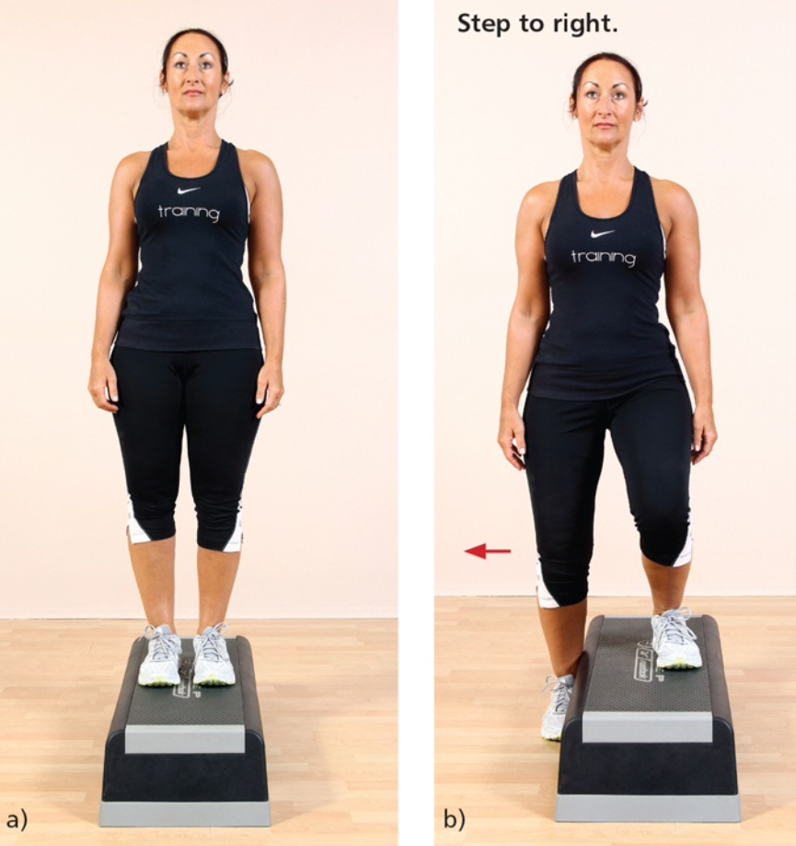
Standing on step on one leg, slowly squat down for opposite leg to tap the floor. Straighten leg on the step. Repeat 2-3 sets of 12-15 reps each leg. Progress by increasing height of step.

3. Lateral Step Down with Lunge
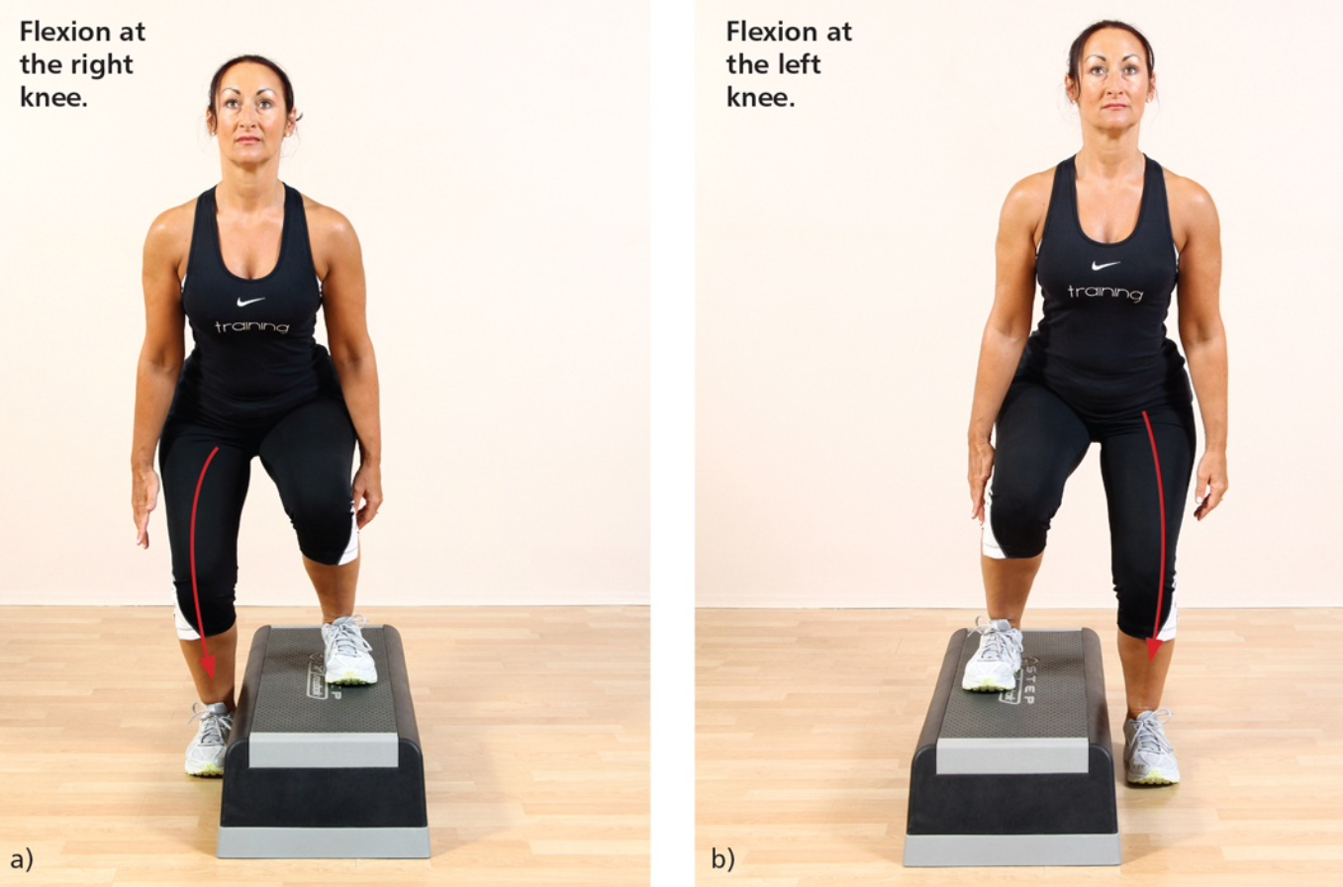
Same steps as above, but when foot contacts floor, perform a lunge. Repeat 2-3 sets of 12-15 reps each leg. Progress by increasing height of step.
Banded Walking Progression
1. Lateral Band Walk
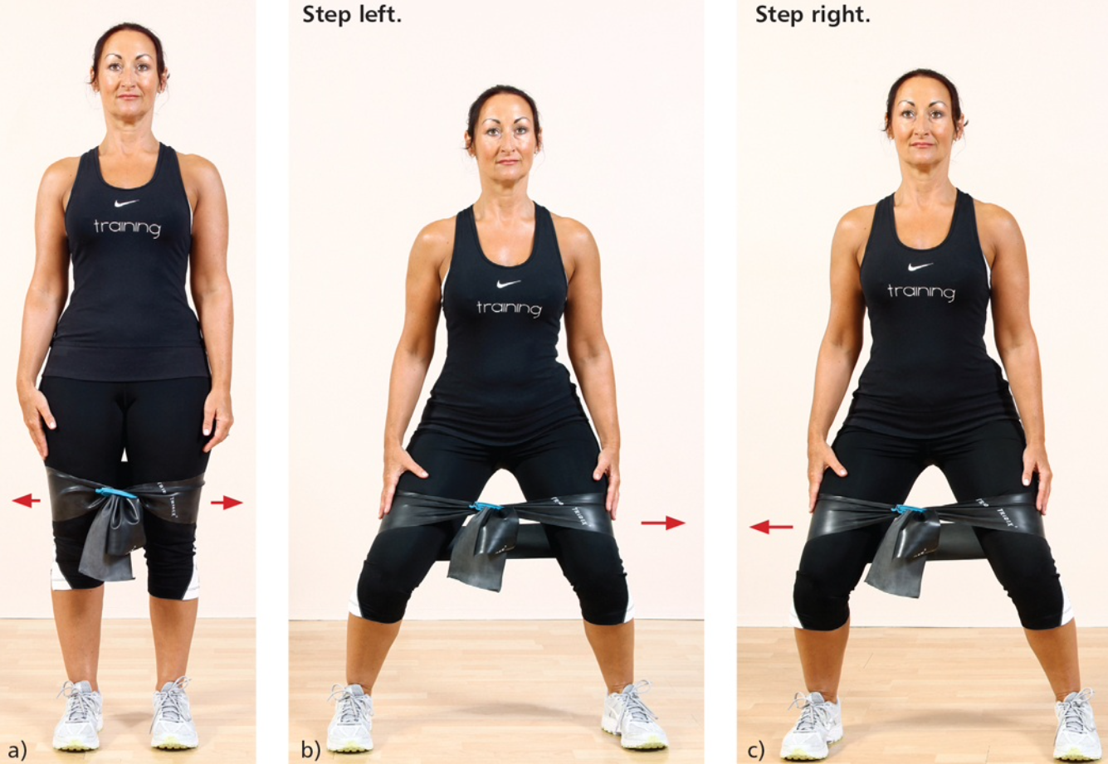
With band around knees and feet shoulder width apart, sidestep to the left about 12-15 steps. Sidestep to the right about 12-15 steps. Repeat 3 times to each side.

2. Monster Walks
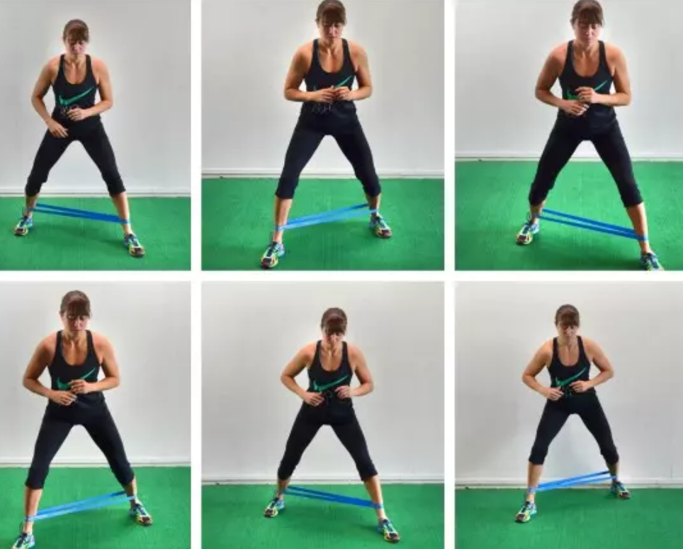
With band around ankles and feet shoulder width apart, take a step forward and out to the side. Then step through, forward, and out to the side with opposite leg. Continue for 12-15 steps. Repeat backwards. Do 3 times forward and backward.

3. Band Drive Thru
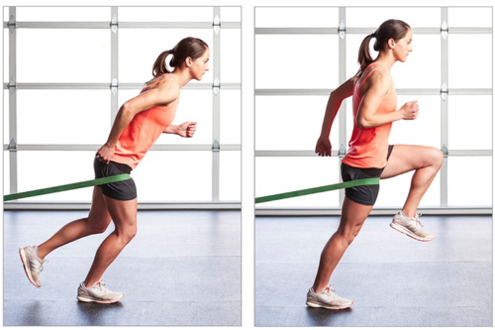
Secure powerband on rack at knee height and step in with one leg facing away from rack. Stand on that leg and drive the knee of the opposite leg forward. Complete 15 reps on each leg.

Miscellaneous Intermediate Exercises
1. Pigeon Hip Extension
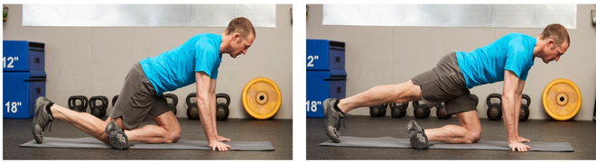
Get into pigeon position on left. Activate glutes to lift back knee off floor and slowly lower back down. Repeat for 2-3 sets of 12-15 repetitions on each side.

2. Swiss Ball Curls
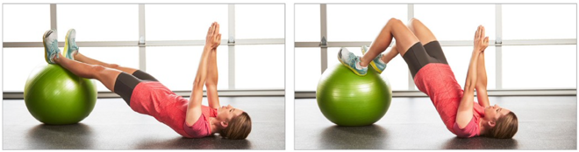
Lie on back with swiss ball under heels/calves. Lift hips up into a bridge and bend knees to bring ball towards you. Complete 2-3 sets of 12-15 reps.

