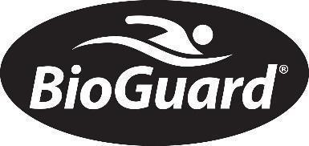
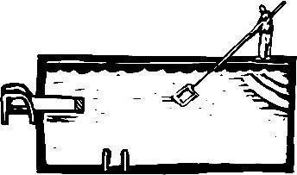
Huntington Woods Pools & Spas
32896 Woodward Ave.
Royal Oak, MI 48073
Huntingtonwoodspools.com
Email: hwpools@yahoo.com
(248) 549-5800

NAME
ADDRESS
CITY ZIP
PRIMARY PHONE
*E-MAIL ADDRESS REQUIRED

Card Number: Exp. date: CVV: AMEX/Visa/Mastercard/Discover

Signature: Date: Print Name:
To make a credit card or ACH payment online visit huntingtonwoodspools.com “Pay My Bill” – type CONTRACT in the ‘invoice number’ field
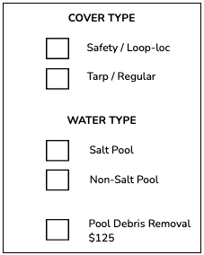
PLEASE SEND US THIS FORM VIA MAIL OR EMAIL WITH UPDATED CREDIT CARD INFORMATION OR CHECK BY 5/1/2026 TO RECEIVE EARLY-BUY PRICING
□ Opening $550 - Early pay discount - credit card $525; check $515
□ Opening w/ Spa $600 – Early pay discount - credit card $575; check $565
□ Partial Opening $275 – Early pay discount - credit card $265; check $260
□ Deluxe Opening $725 – Early pay discount - credit card $700; check $690

□ Closing $560 - Early pay discount - credit card $535; check $525
□ Closing w/ Spa $610 – Early pay discount - credit card $585; check $575
□ Partial Closing $275 – Early pay discount - credit card $265; check $260
□ Deluxe Closing $735 – Early pay discount - credit card $710; check $700
*includes chemical treatment on all closings

Additional Packages (Chemicals to be delivered at opening)
□ Deluxe Tru Blu Package $660: two 25 lb. Bioguard® Silk tabs; 24 lb. Smart Shock; Algae Complete; Pool Complete
□ Mineral Springs Startup Pak $425: 10 bags Mineral Springs Beginnings * saltwater pools*
□ Weekly Vacuum Service $90/HR:
*scheduled by efficient geographical routing and offered Monday through Friday. Clients are not guaranteed to select a specific date. Weekly service does not start until the week of June 1st and continues through Labor day. credit card on file required for weekly service

Open Request Date: 1st Choice 2nd Choice
Closing Request Date: 1st Choice 2nd Choice
*we will notify if your requested date is no longer availableTerms & Conditions

*Offered to EXISTING customers - addresses that utilized Huntington Woods Pools & Spas for open/close services in 2025.
*Pool Opening: Drain/remove/clean pool cover; clean pool deck; clean/shock pool for 1 hour (additional cleaning required billed $90/hr); system start-up and assembly; installation of ladders/diving boards/etc.
*Appointment cancellation required 48 hours in advance. Failure will result in a late fee.
*Pool Closing may require additional charges for supplies such as anchors, water bags, and extra cleaning. Those items will be billed accordingly.
*Deluxe pools: negative edge pools, pools over 1000 square feet, large pools requiring additional crew.
*Please note that we cannot be responsible for turbid water and suspended debris. Pools requiring a second cleaning visit will be billed accordingly.
*Attached spas may require acid wash at an additional price of $100.
*Pool debris and garbage bags will be disposed of at the pool location unless Pool Debris Removal is indicated.
*Prep and drain the pool cover 1 day prior to scheduled opening for ‘regular’ style covers.
*Repairs of leaks, motors, heaters, etc. are not included in the pool opening package, and are billed at service call rates.

