Sunday | Monday | Tuesday | Wednesday |  | Thursday | Friday | Saturday
 |  |  |  | 1  All Fools’ Day  Passover Begins | 2 | 3 | 4
5  Easter Sunday | 6 | 7 |  | 8 | 9 | 10 | 11
12 | 13 | 14 |  | 15 | 16 | 17 | 18
19 | 20 | 21 |  | 22  Earth Day  Administrative Professionals Day | 23 | 24  Arbor Day | 25
26 | 27 | 28 |  | 29 | 30

CBRF |  |  | 9:15Sit n Fit  10:00 Catholic Services  1:15 BINGO! | 9:15 Sit n Fit  10:00 Bible Study  10:30 Women’s Club  2:00 Social Hour | 9:15Sit n Fit  10:30 Daily Chronicles  1:30 Story Circle  2:00 Music and Memories | 
 | 9:15 Sit n Fit  10:00 Bible Study  10:00 Lutheran Services  1:15 BINGO! | 9:15Sit n Fit  10:15 Accordion w/ Karen *RCAC  1:30 Shepherd’s Care | 9:15Sit n Fit  10:00 Catholic Services  1:15 BINGO! | 9:15 Sit n Fit  10:00 Bible Study  10:30 Spa Day  11:30 Sweetberry’s Outing  2:00 Social Hour | 9:15 Sit n Fit  10:30 Trivia  1:30 Story Circle  2:00 Movie | 
 | 9:15 Sit n Fit  10:00 Bible Study  10:00 Lutheran Services  1:15 BINGO! | 9:15 Sit n Fit  10:30 Music by Dan Lovett  2:00 Art N Crafts | 9:15Sit n Fit  10:00 Catholic Services  1:15 BINGO! | 9:15Sit n Fit  10:00 Bible Study  10:30 Men’s Club  2:00 Social Hour | 9:15 Sit n Fit  10:30 Resident Council  1:30 Story Circle  2:00 Recipe Swap | 
 | 9:15 Sit n Fit  10:00 Bible Study  10:00 Lutheran Services  1:15 BINGO! | 9:15Sit n Fit  10:15 Accordion w/ Karen *RCAC  1:30 Shepherd’s Care | 9:15Sit n Fit  10:00 Catholic Services  1:15 BINGO! | 9:15Sit n Fit  10:00 Bible Study  10:30 Spa Day  10:30 Music w Jamie & Laurie  2:00 Social Hour | 9:30 Sit n Fit  10:30 Trivia  1:30 Story Circle  2:00 Food Club | 
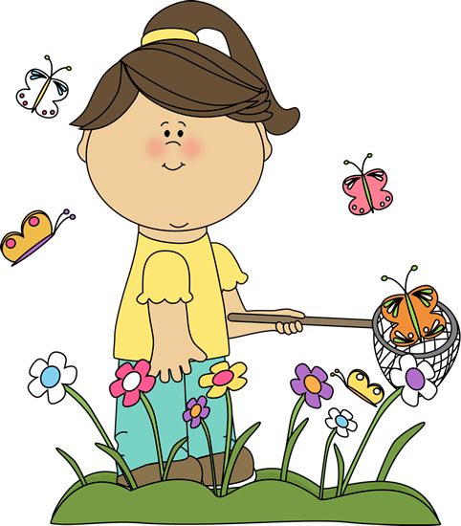 | 9:15 Sit n Fit  10:00 Bible Study  10:00 Lutheran Services  1:15 BINGO! | 9:15Sit n Fit  10:15 Sing Along  2:00 Monthly Birthday Party w Folks Like Us | 9:15Sit n Fit  10:00 Catholic Services  1:15 BINGO! | 9:15Sit n Fit  10:00 Bible Study  10:30 Women’s Club    2:00 Social Hour | April showers  bring  May flowers!

*Activities subject to change for spontaneous fun.

