Sunday | Monday | Tuesday | Wednesday | Thursday | Friday | Saturday
 |  |  |  |  | 1 | 2
3 | 4 | 5 | 6 | 7 | 8 | 9
10 | 11 | 12 | 13 | 14 | 15 | 16
17 | 18 | 19 | 20 | 21 | 22 | 23
24 | 25 | 26 | 27 | 28 | 29 | 30
31

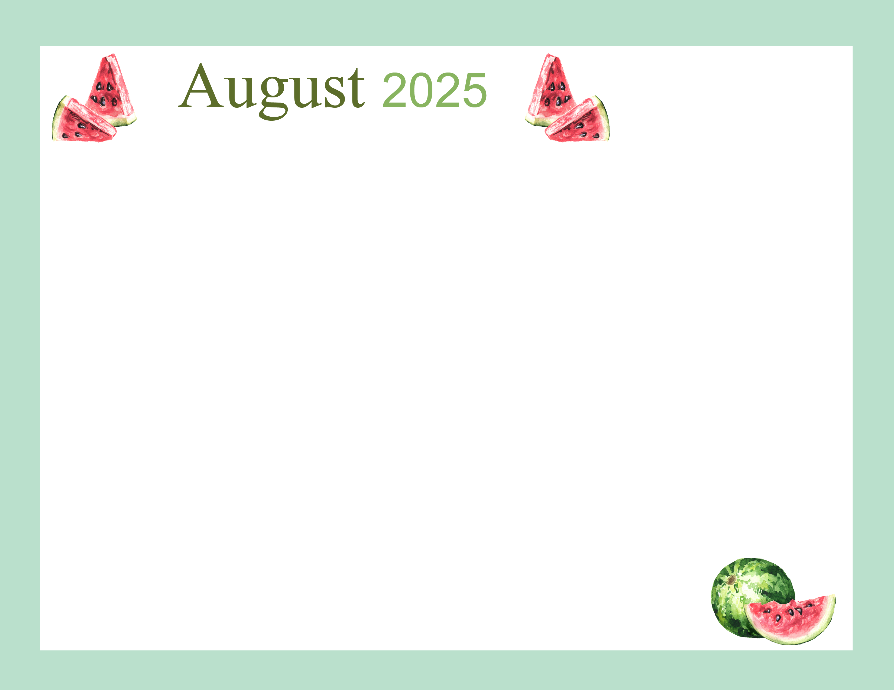  CBRF |  |  |  |  | . 9:15 Sit n B Fit  10:30 Daily Chronicles & Table Talk  1:30 Story Circle  2:00 Elvis | 
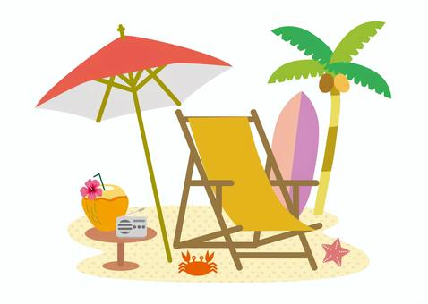 | 9:15 Sit n B Fit  10:00 Bible Study  10:00 Lutheran Services  1:15 BINGO!  2:15 Sensory Stim | 9:15 Sit n B Fit  10:15 Violin w Choe  2:00 Therapy Horses | 9:15 Sit n B Fit  10:00 Catholic Services  1:15 BINGO!  2:15 Sensory  Stim | 9:15 Sit N B Fit  10:30 Men’s Club  2:00 Social Hour/Table Games | 9:15 Sit n B Fit  10:30 Shepherds Care  1:15 Movie Outing | 
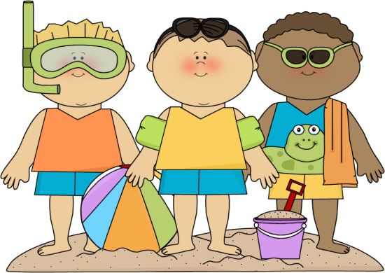 | 9:15 Sit n B Fit  10:00 Bible Study  10:00 Lutheran Services  1:15 BINGO!  2:15 Sensory Stim | 9:15 Sit n B Fit  10:15 Accordion w/ Karen  2:00 Frogg’s Ice Cream | 9:15 Sit n B Fit  10:00 Catholic Services  1:15 BINGO!  2:15 Sensory  Stim | 9:15 Sit N B Fit  10:30 Spa Day  2:00 Social Hour/Table Games | 9:15 Sit n B Fit  10:30 Resident Council  1:30 Story Circle  1:00 “SHOW N TELL” | 
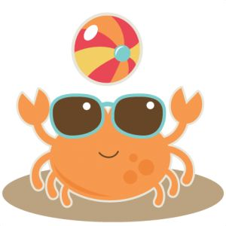 | 9:15 Sit n B Fit  10:00 Bible Study  10:00 Lutheran Services  1:15 BINGO!  2:15 Sensory Stim | 9:15 Sit n B Fit  10:15 Sing Along  2:00 Food Club | 9:15 Sit n B Fit  10:00 Catholic Services  1:15 BINGO!  2:15 Sensory  Stim | 9:15 Sit N B Fit  10:30 Women’s Club  2:00 Social Hour/Table Games | 9:15 Sit n B Fit  10:30 Shepherds Care  1:30 Story Circle  1:15 Mystery BINGO! | 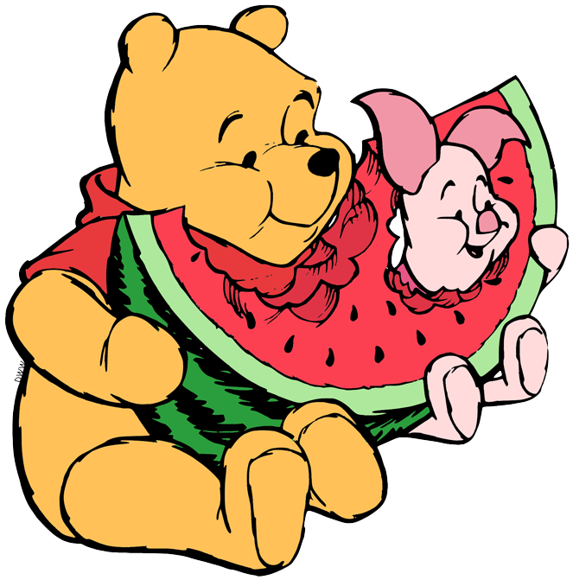
 | 9:15 Sit n B Fit  10:00 Bible Study  10:00 Lutheran Services  1:15 BINGO!  2:15 Sensory Stim | 9:15 Sit n B Fit  10:15 Accordion w/ Karen  2:00 Monthly Birthday Party w Stevie Keys | 9:15 Sit n B Fit  10:00 Catholic Services  1:15 BINGO!  2:15 Sensory  Stim | 9:15 Sit N B Fit  10:30 Spa Day  2:00 Social Hour/Table Games  6:00 Family Night | 9:15 Sit n B Fit  10:30 Trivia  1:30 Story Circle  2:00 Dog Days w  Winston | 
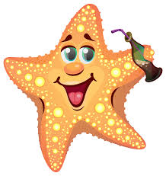 | “Live in the sunshine, swim in the sea,  drink the wild air.” --Ralph Waldo Emerson
*Calendar subject to change for spontaneous fun!

