
Country Villa Little Chute
August 2025
Country Villa Little Chute | 1415 W. Main St. 54911 | 920.788.3444|
August Birthdays  CBRF  7th Joann  28th Joan  RCAC  3rd Kathy J.  16th Asako  17th Tim  25th Carl  25th Marian  28th Donna  August’s birthday party will be August 26th at 2:00 pm in the 3rd floor activity room. Music with Stevie Keys will be the entertainment. | As we move into August, we’re savoring the final stretch of summer with sunshine, fresh air and community fun. A heartfelt thank you to our incredible staff who continue to provide care with compassion and joy. Their effort truly makes this a special place to  live and work.  Country Villa will be busy with a variety of fun activities in August. We will have a visit from Elvis, music with Bobby Solberg, our Monthly Birthday Party with Stevie Keys and Family Night on August ***** with *****.  Did you know that Country Villa Little Chute has a weekly Social Hour? Each Thursday at 2:00 pm we gather near the bar area to have drinks, snacks and play table games. Hope to see you at a Social Hour in the future!  
  From the Kitchen:  August 2025  Hello from your kitchen team!  We’ve been cooking up some  summer favorites and enjoying all  the fresh produce. This month,  you will see more garden  veggies and cool desserts.  Did you know that our kitchen  staff provide the treats for the  Monthly Birthday Parties?  From cupcakes, to cakes &  muffins, we’re always ready to  whip up a sweet treat for the  residents.  Administration:  We are happy to welcome  several new residents and team  members this month! Please  take a moment to say hello  and help them feel at home. A  friendly smile and kind word go  a long way—thank you for making  this such a warm and caring  community.  As always, the care of your  loved ones is our top priority.  If you have any questions or  concerns feel free to reach out! | August Dates to Remember:  1st Elvis  18th Music w Bobby Solberg  26th Monthly Birthday Party  Family Night  Nurses Notes:  Good sleep helps with healing, memory and energy. Try to avoid caffeine after 2 pm and aim for a calm bedtime routine. If you’re having trouble sleeping, talk with our team. We’re here to help.  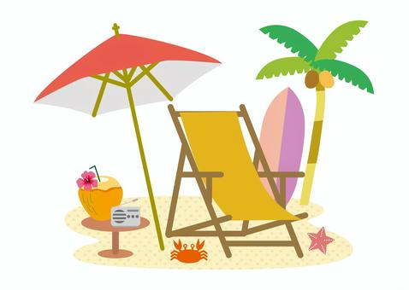
  Title  August 2025  Text. | Title  Text.
 | Postage  Information  Your Mailing Address  Street Number and Name  City, State ZIP Code

Title  Text. | Title  Text.
Your Return Address
Street Number and Name
City, State ZIP Code

