Sunday | Monday | Tuesday | Wednesday | Thursday | Friday | Saturday
 |  |  |  |  | 1 | 2
3 | 4 | 5 | 6 | 7 | 8 | 9
10 | 11 | 12 | 13 | 14 | 15 | 16
17 | 18 | 19 | 20 | 21 | 22 | 23
24 | 25 | 26 | 27 | 28 | 29 | 30
31 | "

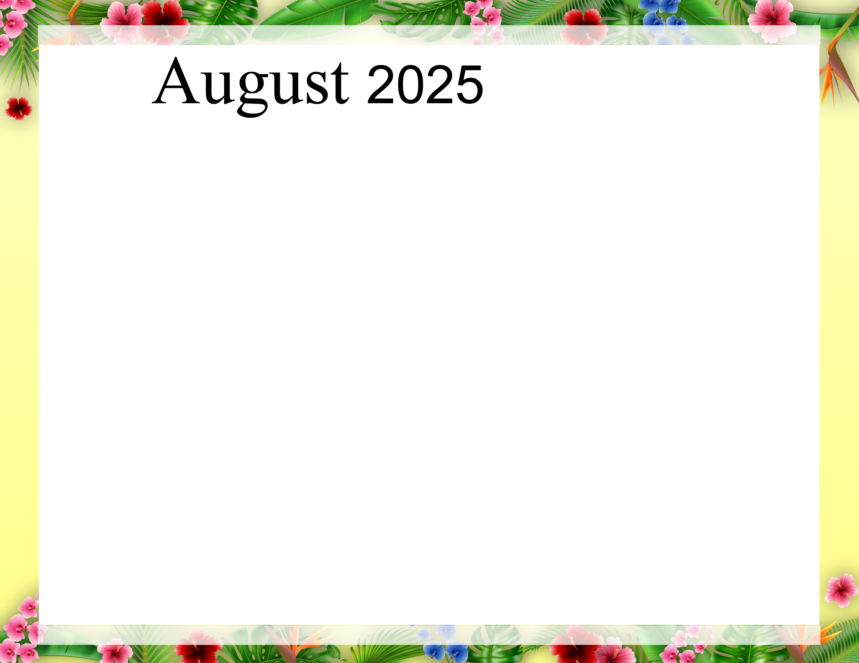  RCAC |  |  |  |  | 9:30 Sit n B Fit  10:30 Daily Chronicles & Table Talk  1:30 Story Circle  2:00 Elvis | 10:30 Chair Yoga  RCAC 3rd Floor  1:30 Sheepshead  RCAC Dining Room
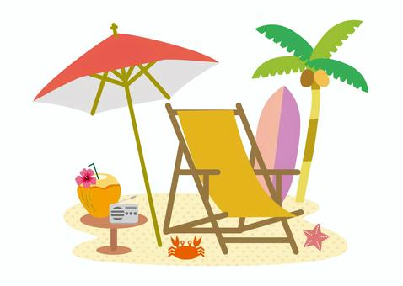 | 8:30 Yoga  9:30 Sit n B Fit  10:00 Bible Study  10:00 Lutheran Services  1:00 Walking Club  2:15 BINGO! | 9:30 Sit n B Fit  10:15 Violin w Chloe  1:00 Walking Club  2:00 Therapy Horses | 9:30 Sit n B Fit  10:00 Catholic Services  1:00 Walking Club  1:30 Story Circle  2:15 BINGO! | 8:30 Fit Plus  9:30 Sit N B Fit  10:30 Men’s Club  1:00 Walking Club  2:00 Social Hour/Table Games | 9:30 Sit n B Fit  10:30 Shepherds Care  1:15 Movie Outing | 10:30 Chair Yoga  RCAC 3rd Floor  1:30 Sheepshead  RCAC Dining Room
 | 8:30 Yoga  9:30 Sit n B Fit  10:00 Bible Study  10:00 Lutheran Services  1:00 Walking Club  2:15 BINGO! | 9:30 Sit n B Fit  10:15 Accordion w/ Karen  1:00 Walking Club  2:00 Frogg’s Ice Cream | 9:30 Sit n B Fit  10:00 Catholic Services  1:00 Walking Club  1:30 Story Circle  2:15 BINGO! | 8:30 Fit Plus  9:30 Sit N B Fit  10:30 Spa Day  1:00 Walking Club  2:00 Social Hour/Table Games | 9:30 Sit n B Fit  10:30 Resident Council  1:30 Story Circle  2:15 Mystery BINGO! | 10:30 No Yoga  1:30 Sheepshead  RCAC Dining Room
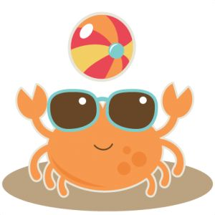 | 8:30 Yoga  9:30 Sit n B Fit  10:00 Bible Study  10:00 Lutheran Services  1:00 Walking Club  2:15 BINGO! | 9:30 Sit n B Fit  10:15 Violin w Chloe  1:00 Walking Club  2:00 Food Club | 9:30 Sit n B Fit  10:00 Catholic Services  1:00 Walking Club  1:30 Story Circle  2:15 BINGO! | 8:30 Fit Plus  9:30 Sit N B Fit  10:30 Women’s Club  1:00 Walking Club  2:00 Social Hour/Table Games | 9:30 Sit n B Fit  10:30 Shepherds Care  1:30 Story Circle  2:15 “SHOW N TELL” | 10:30 Chair Yoga  RCAC 3rd Floor  1:30 Sheepshead  RCAC Dining Room
 | 8:30 Yoga  9:30 Sit n B Fit  10:00 Bible Study  10:00 Lutheran Services  1:00 Walking Club  2:15 BINGO! | 9:30 Sit n B Fit  10:15 Accordion w/ Karen  1:00 Walking Club  2:00 Monthly Birthday Party w Stevie Keys | 9:30 Sit n B Fit  10:00 Catholic Services  1:00 Walking Club  1:30 Story Circle  2:15 BINGO! | 8:30 Fit Plus  9:30 Sit N B Fit  10:30 Spa Day  1:00 Walking Club  2:00 Social Hour/Table Games  6:00 Family Night | 9:30 Sit n B Fit  10:30 Trivia  1:30 Story Circle  2:00 Dog Days w  Winston | 10:30 Chair Yoga  RCAC 3rd Floor  1:30 Sheepshead  RCAC Dining Room
 | “Live in the sunshine, swim in the sea, drink the wild air.” --Ralph Waldo Emerson
*Calendar subject to change for spontaneous fun!

