Berkshire Education Resources K-12
Saturday, May 31, 2025
Time: 9:00 a.m.
Virtual via Zoom

Chair Andrea Wadsworth opened the meeting at 9:04 a.m. and read the following disclosure statement: Although Berkshire Educational Resources K-12 is not a public body under Massachusetts law, its physical or virtual meetings are held in public, the press and public are invited to attend, and an audio or video record, or both, may be made of each meeting. For these reasons no one attending a physical or virtual BERK12 meeting should have an expectation of privacy as regards her/his image, behavior, or utterances made during the meeting.

Introduction / Welcome

Present:
Chair Andrea Wadsworth, Chief Financial Officer in the MA Office of the Comptroller, MASC Past President, Berkshire Region Mass Commission of Status of Women
Dr. William Cameron, Chair Pittsfield School Committee, former BERK12 Chair
John Hockridge, former North Adams School Committee and former BCETF Chair
Vanessa Wassenar, Williamstown, Consultant-Education & Nonprofits
Brian Fairbank, The Fairbank Group
Dr. Will Singleton, former Pittsfield NAACP President and Retired Superintendent, Roosevelt
UFSD.

Also present:
Jake Eberwein, Project Manager
Bill Ballen, BERK 12PD, Study Action Teams, Professional Learning Networks
Brendan Sheran, BERK12 BRLI, Portrait of a Graduate
Kathy Hall, former Lee School Committee member

Approval of Minutes
None

Update for Chair and Executive Committee
Dr. Eberwein spoke about the continuing support from members of the local legislative delegation, including related to rural, regionalization and consolidation supports. A large group from the Mohawk Trail and Hawlemont Regional District did attend Day on the Hill and were able to speak to their representatives and to others about the significance of the funding issues facing small and rural school districts across the Commonwealth.

Budget & funding update (J. Eberwein)
Status of current FY25 funds
NEA pull back
Funding and Project Prospects for FY26
Plans for FY26 (Bridge Funding/Summer)
Approval of FY26 Bridge Funding

Dr. Eberwein told the group that the team is working on an early childhood grant (CPPI) for Pittsfield and have received strong positive feedback from partners about the work on this grant and possibilities going forward.

There have been multiple leadership changes in the County in recent months and will be more going forward. Challenges abound, including declining enrollment, school choice and charter, and last, but not least, funding.

Work done in FY 25 listed below:
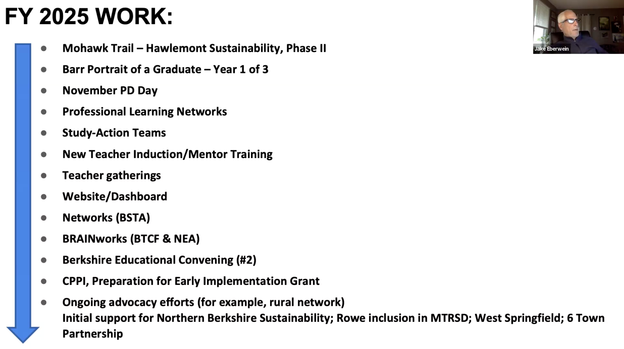

Budget Updates - Closing out FY25
BCC is doing an end of year fiscal audit. Dr. Eberwein noted that a great deal of time is spent with BCC on finances. The relationship is going well.

- FY25 Earmark has been fully expended
- Barr Portrait of a Graduate (first year of three-year grant), is closing out.
- Mohawk Trail - Hawlemont Phase II is completed
- Barr Exit Grant - two year grant - will extend through fall and is mostly encumbered
- BRAINworks
  - The Federal Gov’t pulled back the NEA funding. Lisa Donovan, Leslie Appleget and the team fast-tracked a spending plan, most was expended, but a small amount was returned. They also wrote an appeal, with assistance from the BCC legal team. There is a possibility the legal appeal will be acted upon and there is a chance that the monies “clawed” back will be returned.
- It is likely that Phase III of the Mohawk Trail - Hawlemont project will move forward.
- It is likely that the Northern Berkshire Sustainability project will move forward
- Barr Portrait grant will move into year two of a three-year grant cycle
- It is likely that the Feigenbaum grant will be funded and it will be designated to fund the November PD day and if anything is left over, that will go towards supporting PLNs and Study Action Teams.
- There is a contract to be signed with Pittsfield that would support new teacher induction and mentoring
- There have been conversations with the Pioneer Valley School District and Gill-Montague about helping them through the final stages of bringing a regionalization vote to voters in the spring.
- West Springfield did put out an RFQ, but there was not enough money or clarity about the project; the team did not respond. There was communication with the district about what the RFQ included and the work that would be anticipated.

FY26 Projects (committed and likely)
- Mohawk Trail - Hawlemont sustainability project - Phase II
- Barr Portrait of a Graduate - Year 2 of 3
- November PD Day
- New Teacher Induction and Mentor Training
- Teacher Gatherings
- Website / Dashboard
- BRAINworks (BTCF and NEA), through December 2025
- Networks (BSTA)
- Ongoing Advocacy Efforts (ex: Rural Network)

Possible FY26 Projects (if funded)
- Northern Berkshire Sustainability (FY26 Earmarks)
- 6-Town Partnership (support for community engagement/campaign)

Will Not Happen Without Funding
- Professional Learning Networks (PLNs)
- Study Action Teams
- Berkshire Educational Convening (#3)
- Additional CPPI Work (in Pittsfield or other communities)
- Other Restructuring/Consolidation District Needs
- Other Professional Development

Senator Mark did support a $150,000 earmark that is now in conference committee. More on that after the HWM budget comes out and is signed. This earmark is directed to regionalization and efficiency work with school districts in Berkshire County and Mohawk Trail.

Dr. Eberwein told the committee there is a need for bridge funding to include funding for himself, Brendan Sheran, and anyone else who would be needed, because current funding will end in June. There is additional work to be done managing BERK12 activities, including all of the ongoing work discussed above, report writing, responding to grants, creating a budget and documentation of the earmark is approved; along with planning for fall events. He and Brendan Sheran are working with the Mohawk Trail team, and will begin work with the North County group. There have also been several calls with the Pioneer Valley 6-district partnership.

There are some small accounts held at BCC; those accounts are being reviewed and combined in terms of time-bound and not time-bound. Revolving accounts are not time-bound.

The request is to pay Dr. Eberwein, Brendan Sheran, Bill Ballen, and Judy Rush. That funding would come from specific accounts: Brendan Sheran (2 days a week), Jake Eberwein (2 days a week), from July through October. Funding for Bill Ballen is contingent upon Feigenbaum funds, and additional consulting would come from revolving funds. There is money to cover the four months in revolving and reserves.

MOTION: Bill Cameron made a motion, seconded by Will Singleton, to authorize transfer (from Revolving Account) of up to $50,00 for staff, as described (above) by the Project Manager, Dr. Eberwein, Sheran, consultant; Ballen coming from Feigenbaum funding. The motion carried unanimously.
Collaborative projects
Portrait of a Graduate: (B. Sheran)
BRAINworks: (L. Donovan)
CPPI, Pittsfield (Team)
Other

Brendan Sheran provided an update on the Barr Inspirational Visit to Washington, DC. The team visited the extremely large Fairfax County District. The Barr project has been ongoing for over 10 years. There were conversations with administrators, principals, teachers and students on the work that they have been doing. Students shared about their development and growth toward the competencies identified. The Team visited the EL Haynes Charter School where the focus was on cultivating student voice and engaging learners in that particular school.

The team was able to work together, and with other teams in the network, to consider refining the plans to be better aligned and coherent for the coming years to ensure the right fit for our schools. There will be more intentional focus next year on various strategies that help students demonstrate and communicate their learning.

There are summer workshops in development to offer the opportunity for teams to continue to work on connecting literacy instruction to the portrait and competencies that have been developed.

The Student Summit held at BCC brought together about 70 students from various schools to discuss the meaning and purpose of high school. Students participated in a range of sessions facilitated by their peers. Students worked to develop statements to bring back to their schools. All POG schools sent teams; all other schools were invited and Lenox did send a team of students.

Jake Eberwein gave an update on the Commonwealth Preschool Partnership Initiative (CPPI), which is managed through the Pittsfield Public Schools. The program engages multiple community agencies in the work of expanding access, equity, and elevating quality of pre-K programming with a focus on 4-year olds. Key priorities of the grant are affordability, access, and equitable delivery of services for students with identified needs or those who come from disadvantaged backgrounds.

BERK12 was engaged to assist in writing the grant. The work has involved updating the needs assessment, draft strategic plan writing, and some cost analysis. The partnership is in the process of reviewing the draft strategic plan. The work on the CPPI grant application will finish in June.
Bill Ballen gave an update on PD planning: Judy Rush and Howie Martin are organizing the New Teacher Induction work. Judy Rush has been doing NTI and mentoring work for years and he hopes the PD day can continue moving that work forward for years to come

Out of School Time event held in the spring was very successful and was attended by many of our partners and some of our funders. The continuing work of OST is contingent upon funding.

The Professional Learning Networks have been in existence in BC for over fifteen years. The hope is to continue the work of the PLNs next year.

Study Acton Teams will continue if funding is available. Study Action Teams will be restructured going forward. Next year the hope is to have ten networks, pending funding.

November PD Day will include sessions for all specialists this year. There is optimism around funding from the Feigenbaum Foundation. They want to see as many districts as possible working collaboratively to offer solutions to the needs that exist. Some districts are transitioning to the Monday and Tuesday prior to Thanksgiving. There is consideration being given to transitioning to those days in two years, rather than having the districtwide PD on Election Day, if there is enough interest from school districts.

Brendan Sheran updated on BRLI: three and a half hour sessions were hosted at the Innovation Center, on topics including data, privacy, and AI at the elementary level. The sessions included solid conversations among attendees. A survey will go out to learn more about how ed tech practices are being utilized across the County.

There is an AI focused workshop scheduled for June. This is exciting because participants will be paid and can earn up to ten PDPs. Casey Daigel from CES will present on Boundaries and Breakthroughs - Crafting Shared Guidelines for AI. The overarching goals are to provide people with real world skills and ways to integrate AI into their practice. There will be time to collaborate on drafting guidelines for AI use. The group at this session will also consider limitations, academic integrities, and consideration of modifications that might be necessary to prevent over-reliance on AI.

Dr. Eberwein referred members to the syllabus included in the PPT presentation for the New Teacher Induction programming.

He is working on possibilities for website transition with a colleague. The website was funded for a period of years, but there are resources available that would be less costly than the current vendor. Square Space sites are one good example of a more cost-effective option. More will be coming on that.

Mohawk Trail / Hawlemont work: The Steering Committee, which is not a formal planning board, produced a report based on their vote to move forward with the recommendation to become a single district. Each school committee then voted to move forward with that recommendation. The two districts have already applied to MSBA to consolidate the elementary schools on a single site. That would result in a one-site preK-12 school district, involving eight, and potentially nine, communities. Rowe currently transitions most of its high school students into Mohawk Trail and is considering joining the regional district. The work moves next to developing a Regional Agreement; that work should be complete by fall of 2026. There is a large amount of relevant data on the website, 6towns.org, about that work.

The team has met with the North Berkshire group, including participants from the select boards and their Mayor. They have asked for suggestions on how they might move forward. That North Berkshire group will meet in early June to talk about funding streams and how to move forward. That group will also be meeting with the Secretary of Education to talk about potential funding for that work. The prospect for continuing work there looks good.

Dr. Eberwein will be meeting with Senator Mark to talk about expectations around the earmark and how funds will be apportioned to the needs of the work.

Dr. Cameron suggested having a delegation from BERK12 meeting with the new Commissioner to talk about the work that has been accomplished in Berkshire County. BERK12 and the management team have built credibility through the work that has been ongoing.

Items Raised by BERK12 Members
None

Items Raised by Members of the Public
Kathy Hall, retired Lee School Committee member, expressed joy at being able to follow the exceptional work being done by the management team and the BERK12 board.

Next Meeting Date
August 19, 2025, 9:00 a.m., virtual via Zoom.

Adjournment
MOTION: Bill Cameron made a motion, seconded by Vanessa Wassenar, to adjourn. The motion carried unanimously. The May 31, 2025 meeting of BERK12 adjourned at approximately 10:37 a.m.

