

INSTITUTIONAL ACCREDITATION / APPROVALS

The school holds an institutional accreditation through the Accrediting Bureau of Health Education Schools
(ABHES), which is located at 6116 Executive Blvd., Suite 730, North Bethesda, MD 20852. Additionally, the school is licensed by the California Bureau for Private Postsecondary Education which is
located at 1747 North Market Blvd. Suite 225, Sacramento, CA 95834.
Approved local and statewide training provider for the State of California for training for WIOA, EDD, DOR, TRA.
State of California Radiologic Health Branch (RHB) Approval.

Veteran training approval for eligible candidates to utilize their GI Bill® Benefits/ Vocational Rehab Benefits.
GI Bill® is a registered trademark of the
U.S. Department of Veterans Affairs (VA). More information about education benefits offered by VA is available at the official U.S.
government Web site at http://www.benefits.va.gov/gibill.

Alternative Course Offering Format
DISTANCE LEARNING

Utilizing a combination of online lecture notes, group discussions, interactive media, didactic, and laboratory
studies.

Medical Assisting with Limited Permit X-Ray Technician

MEDICAL CAREER COLLEGE OF NORTHERN CALIFORNIA

1220 MELODY LANE STE. 140
ROSEVILLE CA, 95678
916.721.7106

WWW.MEDICALCAREERCOLLEGE.EDU
mccnc2000@gmail.com

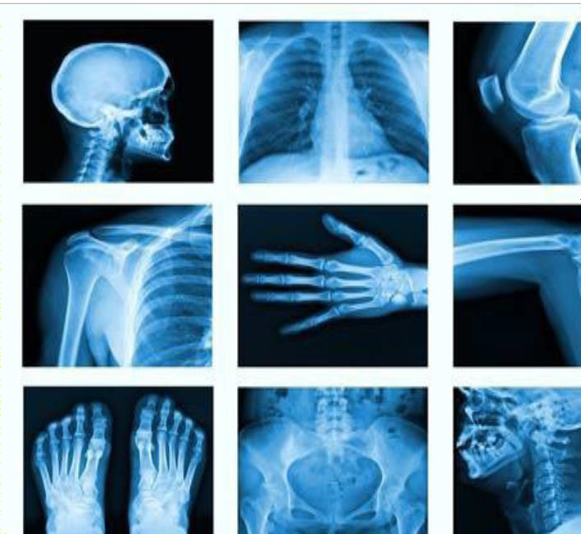
ADMISSION AND GRADUATION REQUIREMENTS

ADMISSION REQUIREMENTS
Applicants for admission must possess a High School Diploma, High school Equivalency or GED to be considered eligible for admission to the program. All applicants must achieve a minimum passing score of 23 on the school’s entrance exam. Classes are taught in English. The student must demonstrate the ability to read and write in standard English.

GRADUATION REQUIREMENTS
Students must complete all areas of the program with a cumulative GPA of 75% or better and satisfactorily complete the externship program in an approved medical facility. In addition, students must satisfy all of their financial obligations to the school to receive their certificates.

HOW TO ENROLL
Requests for an admission application or course catalog may be made in writing to Medical Career College of Northern California at 1220 Melody Lane Suite 140 Roseville CA, 95678 or by emailing the school at MCCNC2000@GMAIL.COM.
Forms may also be found on our website to download.
The school recommends that interested students call for an appointment to visit the classroom and discuss the program with an Admissions Representative.

DIDACTIC TRAININGAND EXTERN HOURS
Quarter 1 – 160 hours for 10 Weeks (GE101, MACB102)

Quarter 2 – 160 hours for 10 Weeks (RT101, RT102, RT103, RT104)
Quarter 3 – 200 hours for 10 Weeks (RT201, RT202, RT203, RT204)

Quarter 4 – 200 hours for 10 Weeks (RT301, RT302, RT303, RT304)
Quarter 5 & Quarter 6 – Completion of 600 hours of Externship Experience

PROGRAM OPPORTUNITIES
Provide training on the basic knowledge and skills for individuals interested in a career as a Medical Assistant with Limited Permit X-Ray Technician. A certificate will be awarded to students who successfully complete the requirements of the program. Students who are enrolled in the program are admitted with the goal of obtaining a State of California Limited Permit X-Ray Technician License.

PROGRAM DESCRIPTION
Hours of Instruction provided: 1320
Outside Preparation Hours: 303
Weeks of Instruction: 60 Quarter Credits: 83.5
Didactic courses are taught in a Hybrid format and Lab Classes are in residence at the school site.
Students are required to complete numerous classroom quizzes, laboratory procedures, hands on positioning and homework assignments.
Additionally, students will be required to take the midterm and final exams, show proficiency in positioning as well as competency in back-office medical assisting skills.
The MA/LPXT externship will begin in the 3rd Quarter when the student demonstrates basic knowledge and skills necessary to begin taking radiographs. The LPXT extern consists of documented proof of 50 Chest Exams, 50 Upper Extremity, 50 Lower Extremity and 200 Torso- Skeletal exams.

