

2026 Outing Rates

Shotgun Start:
Shotgun Player Minimums: Monday - Thursday 50 players. Friday, 50-80 players for a modified shotgun, 120 or more for a full course shotgun.

Monday 10:00 AM or before $44.00
Monday after 10:00 AM $47.00
Tuesday - Thursday 10:00 AM or before $49.50
Tuesday - Thursday after 10:00 AM $53.00
Friday 9:00 AM or before $57.00

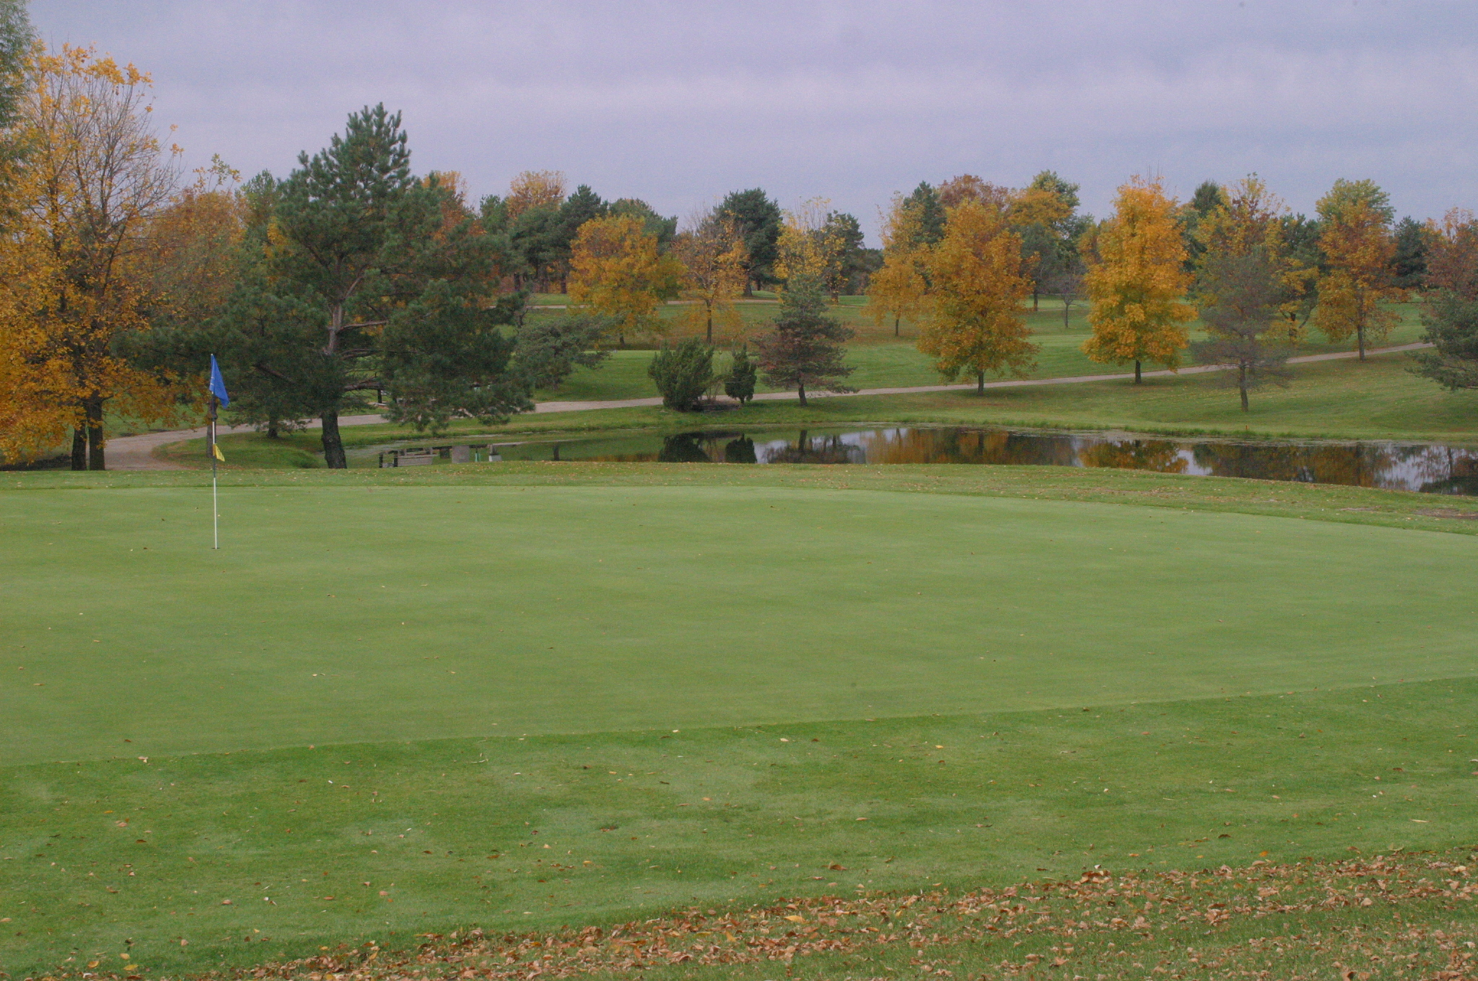
Rates do not include Iowa Sales Tax.
216 Player Single Shotgun Capability
9 Hole Rates available upon request.
Tee timed outings of any size are also welcome at Beaver Creek. We are able to offer these types of events seven days a week. We use our standard daily rates for tee timed events. These rates are available at our website.

Services Provided for your outing
- Four non-outing golf passes will be given to all outings ($220 value).
- Registration area.
- Announcements prior to event.
- Name cards on each cart with hole assignments.
- Flag events/Hole Contests.
- Preprinted scorecards with participants names.
- Outing information sheets describing the format of your event, location of flag events and any other information you would like to add.
- Score the event upon completion of play.

Contact Brett Long, Clubhouse General Manager Tel. 515-986-9524
Website Address: www.beavercreek-golf.com
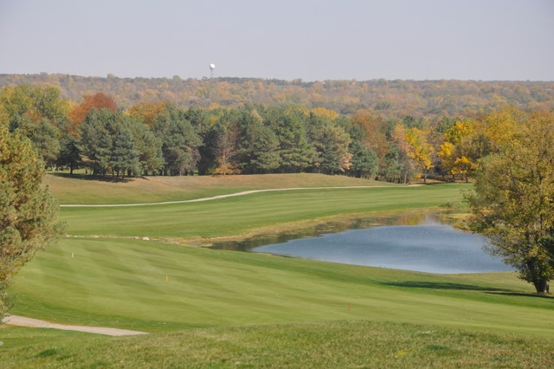
Golf Outing Policies

Thank you for considering Beaver Creek Golf Club for your outing. The following is a list of policies that we follow to insure a positive golfing experience for your group. Please contact us with any questions you might have.

- Before your outing is added to our schedule, we must have the Participant’s Guarantee form signed and returned.
- All participants must ride golf carts. Only 2 players and 2 bags per golf car.
- Golf cars must be treated with respect. Incorrect use of golf cars will not be tolerated.
- The person scheduling the outing and/or signing this outing agreement is responsible for all damage to the course, golf cars and surrounding properties by the outing participants.
- No one may bring outside alcohol on to Beaver Creek property. Iowa law prohibits bringing your own alcoholic beverages to Beaver Creek Golf Club.
- Only Beaver Creek employees are allowed to serve from the beverage carts.
- No underage drinking will be allowed at Beaver Creek.
- Beaver Creek holds the right to refuse service to anyone.
- Proper golf attire is required at Beaver Creek Golf Club. Shirts and shoes must be worn at all times.
- A reasonable pace of play must be maintained by your entire group.
- A 3% credit card service fee will be added to all credit card outing payments.

Beaver Creek Golf Club - Telephone 515-986-3221

2026 Participant’s Guarantee:

Outings must contact Beaver Creek Golf Club prior to the outing date with confirmation of final number of players. All policies in this information packet are enforced so that your group and all other golfers can enjoy their golfing experience at Beaver Creek Golf Course. Your booking of an outing acknowledges that you have read and understand these policies and agree that your entire group will abide by them.

Company Name: ________________________________________________

Date of Outing: ____________________ Second Choice: ________________

Start Time: _________________ Tee Time or Shotgun (circle one)

Number of Players: __________

Meal: Yes/No (circle one) Beverage Tab: Yes / No (circle one)
Meal choice may be made later. Food Tab: Yes / No (circle one)
Drink Tickets: Yes/No (circle one)

Drink ticket options are explained on our menu page, in the outing packet.

Contact Person: ________________________________________________

Phone #:___________________________ Fax: _______________________

Email: ________________________________________________________

Billing Address: ________________________________________________

_________________________________________Zip _________________

Signature: _____________________________ Date: _________________

A 3% Credit Card service fee will be added to all Credit Card Outing Payments.

Please return this page to: Beaver Creek Golf Course.
Attn. Brett Long, 11200 NW Towner Drive, Grimes, IA 50111

