Super El Niño Is Taking Shape: What It Means Heading Into Fall and Winter

A powerful El Niño is rapidly strengthening across the tropical Pacific Ocean, and the latest data suggests the developing 2026–27 event could eventually rank among the strongest ever observed.
El Niño is a natural climate pattern caused by unusually warm ocean water developing across the central and eastern equatorial Pacific. While this warming happens thousands of miles away from much of the United States, it can rearrange weather patterns around the world by changing where thunderstorms develop over the tropics and, in turn, altering the position and strength of the jet stream.
In short, when the tropical Pacific Ocean changes, the atmosphere above it changes too. These changes can eventually influence weather across much of the globe, which are surely to occur that’ll be felt heading into this fall and especially into the winter of 2026-27.

Current Magnitude of El Niño Right Now
The latest data shows that the tropical Pacific has become exceptionally warm. According to Celsius Earth, the Niño 3.4 region — the main area scientists monitor when measuring El Niño — is currently running around 2.75°C above its 1996–2025 average based on the latest seven-day mean. That is firmly within what would commonly be described as a very strong or “Super El Niño” level.
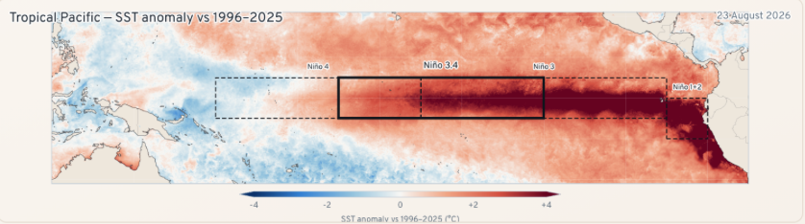
(Credit: Celsius Earth)
The most recent Celsius Earth briefing showed Niño 3.4 at +2.69°C, an increase of roughly 1.56°C in only 90 days. The warmth is even more impressive farther east. At the time of that briefing, the Niño 3 region was +3.26°C and Niño 1+2, immediately west of South America, was an extraordinary +4.26°C.
This is important because the warming is not confined to one tiny part of the Pacific. A large portion of the equatorial Pacific is now significantly warmer than normal, providing an enormous source of heat and moisture that can interact with the atmosphere.
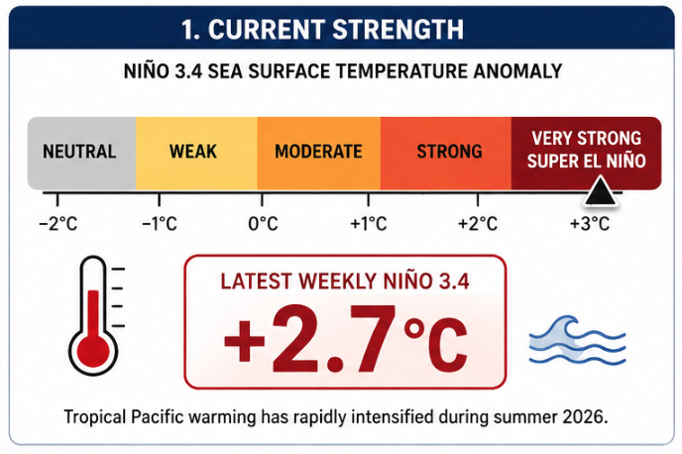

What Does “Super El Niño” Actually Mean?
“Super El Niño” sounds dramatic, but it is important to understand that it is not an official NOAA classification.
Scientists generally describe El Niño events as weak, moderate, strong or very strong based partly on how warm the tropical Pacific becomes. The term “Super El Niño” is commonly used informally for the rare events that reach the upper end of that scale, particularly when Niño 3.4 temperatures approach or exceed about 2°C above normal.
Only a handful of El Niño events in the modern record have reached that territory.The famous 1982–83, 1997–98 and 2015–16 El Niños are among the benchmark events against which extremely strong El Niños are often compared. As this time, the developing 2026 event is now entering that conversation.

NOAA Is Now Warning of a Potentially Historic Event
Perhaps the biggest development came with NOAA's August update. NOAA's Climate Prediction Center says there is now a greater than 90% chance that El Niño becomes a very strong event during fall and winter 2026–27. Even more remarkable, NOAA calculates a 69% chance that the October–December 2026 period reaches a three-month Relative Oceanic Niño Index of +2.5°C or greater. That would exceed the strength of previous El Niño events in NOAA's record going back to 1950.
In other words, NOAA is not simply forecasting a strong El Niño anymore. There is now a legitimate possibility that, by this particular measurement, the developing event reaches historic territory.
El Niño is also expected to stick around for quite some time. The latest international model guidance gives El Niño essentially a 100% probability of continuing through the winter and into early 2027, with the odds remaining very high into spring.
That doesn't mean El Niño will remain at peak intensity for that entire period. These events typically strengthen during fall, peak sometime around late fall or winter, and then weaken during the following spring.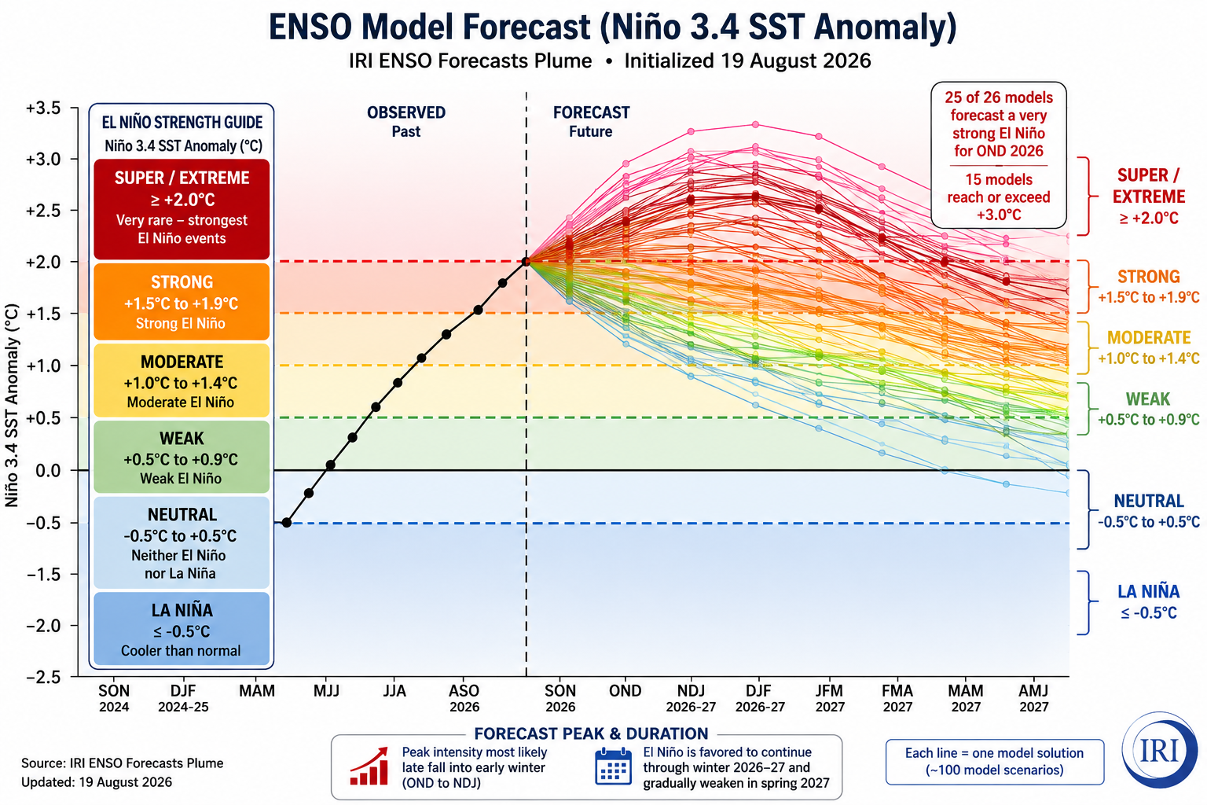

Why Is the Pacific Warming So Quickly?
An El Niño isn't simply warm water sitting on top of the ocean. The ocean and atmosphere begin working together. Normally, tropical trade winds blow from east to west across the Pacific.
During El Niño, those winds weaken or sometimes temporarily reverse. Warm water that is normally piled up toward Indonesia and the western Pacific can spread eastward toward the central and eastern Pacific.
At the same time, warmer water beneath the ocean surface can rise and reinforce the warming at the surface. As this process strengthens, thunderstorms that normally favor the western tropical Pacific can shift eastward as well. That changes enormous atmospheric circulations extending thousands of miles beyond the tropics.
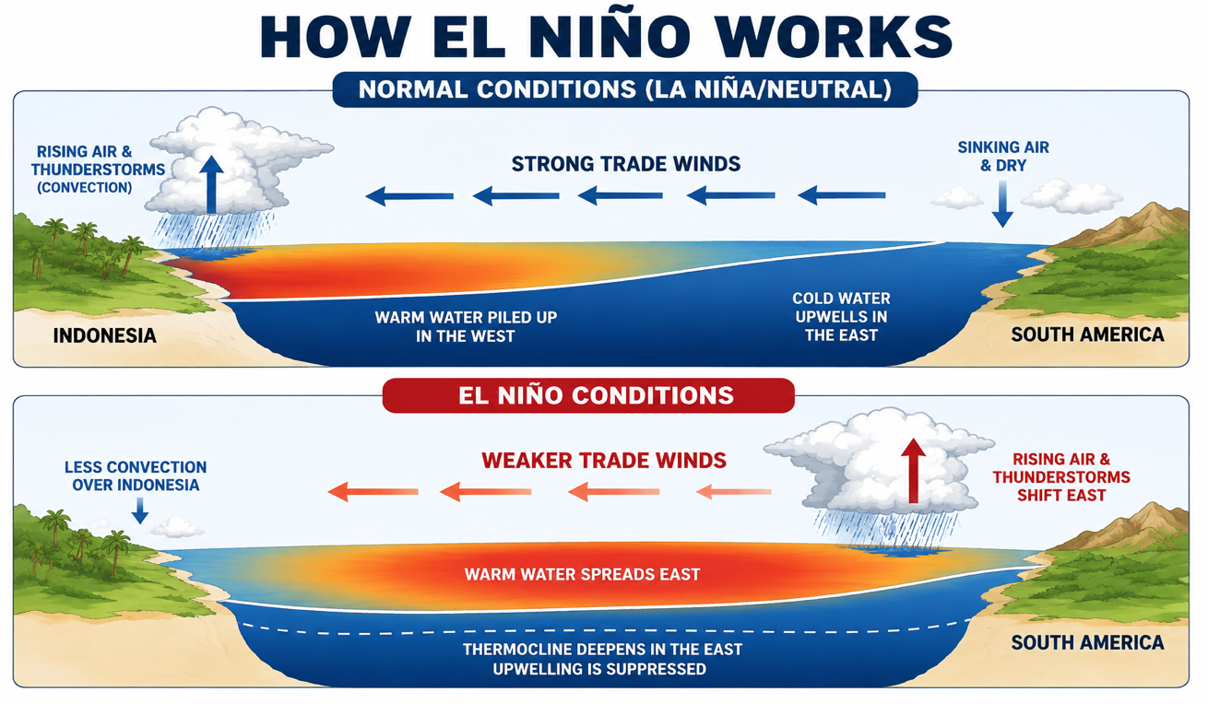
Think of the tropical Pacific as one of the atmosphere's largest engines. El Niño changes where that engine is releasing its heat. The atmosphere then responds.

Implications for the United States
The effects of El Niño typically become much more noticeable across the United States during fall and especially winter. A strong El Niño tends to strengthen and reposition the Pacific jet stream, often sending more storms across the southern United States. Historically, this can favor a wetter and stormier southern tier, including portions of California, the Southwest, Gulf Coast and Southeast.
Across the northern United States, the average El Niño pattern tends to favor milder conditions, particularly from the Pacific Northwest through portions of the northern Plains, Great Lakes and Northeast.
NOAA's latest seasonal outlook is showing some of these classic characteristics. Above-normal temperatures are favored across significant portions of the northern United States, while increased precipitation chances appear across portions of the southern tier as winter approaches.
It should be noted that El Niño does not provide a day-to-day weather forecasts. Furthermore, a strong El Niño does not mean every southern location will be wet, every northern location will be warm, or that certain cities will or won't receive snow. Rather, El Niño loads the atmospheric dice toward certain large-scale patterns over the course of an entire season.
Individual storms, cold outbreaks, snowstorms and warm spells will still depend on shorter-term atmospheric patterns that cannot be predicted months in advance.

Continued Quiet Atlantic Hurricane Season

El Niño commonly increases upper-level winds, or wind shear, across portions of the tropical Atlantic and Caribbean providing an increasingly hostile background influence for hurricanes. This is what we’ve seen thus far, which has historically resulted in lowest start to hurricane season dating back to when records began.
Tropical storms and hurricanes generally prefer an atmosphere where winds don't change dramatically with height. Strong wind shear can tilt thunderstorms away from a developing storm's center and make it harder for a tropical cyclone to organize or strengthen.
That does not mean hurricanes cannot develop during El Niño years. Warm Atlantic waters and short periods of favorable atmospheric conditions can still allow significant storms to form. It simply means El Niño tends to make the overall Atlantic environment less favorable than it otherwise would be
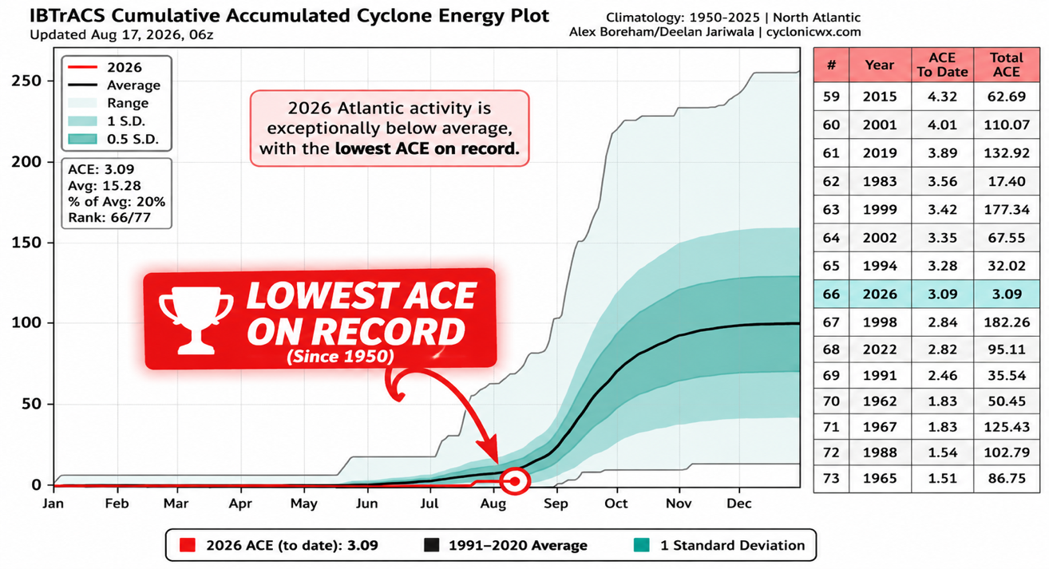

El Niño's Reach Goes Far Beyond the United States

The effects of a major El Niño can be felt across much of the planet, although the exact impacts vary from event to event. Across parts of western South America, especially Peru and Ecuador, El Niño can dramatically increase rainfall and flood risk as unusually warm Pacific waters enhance thunderstorms.
Parts of Indonesia and Australia often experience increased risk of hotter and drier conditions, which can contribute to drought and wildfire concerns. Across portions of East Africa, El Niño can favor increased rainfall during certain seasons, sometimes resulting in significant flooding.
The Indian monsoon, weather patterns across southern Africa, tropical cyclone activity in multiple ocean basins and even weather patterns extending toward North America can all be influenced to varying degrees.
The effects aren't identical everywhere, and they don't happen simultaneously. El Niño works more like a massive shift in the global climate system than one single worldwide weather event.
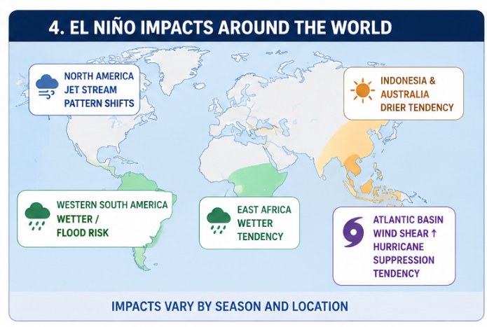

The Bottom Line
The next several months will be extremely important. El Niño events commonly reach their maximum strength during the late fall or winter, meaning the developing 2026 event may still have additional room to intensify.
The latest observations already show exceptionally warm water stretching across the equatorial Pacific, while computer models overwhelmingly agree that El Niño will persist through the upcoming winter.
NOAA's latest forecast gives a greater than 90% chance of a very strong El Niño and a 69% chance of reaching a level that would exceed previous events in its record by the October–December period.
Those are extraordinary probabilities for a climate phenomenon that only a few months ago was still developing, but strength alone doesn't determine exactly what happens this winter.
Where the warmest Pacific water ultimately becomes concentrated, how strongly the atmosphere responds, the behavior of the polar vortex, other ocean patterns and shorter-term atmospheric variability will all help determine how the winter unfolds.
The 2026 El Niño has gone from a developing climate signal to one of the biggest weather and climate stories heading into fall. Pacific Ocean temperatures have risen remarkably quickly. Niño 3.4 is currently running roughly 2.75°C above its recent average, and NOAA now believes there is a greater than 90% chance of a very strong El Niño during fall and winter.
There is even a significant possibility that one measure of this event reaches levels not seen in the modern NOAA record. That does not guarantee an extreme winter — and it certainly doesn't tell us exactly how much snow or rain any particular city will receive.
In general, it does tell us is that one of Earth's most influential climate patterns is becoming exceptionally strong. As we move deeper into fall and toward the winter of 2026–27, its influence on weather patterns across the United States and around the world is likely to become increasingly important.

