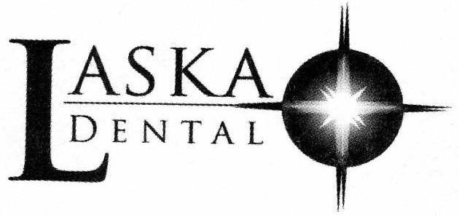

How would you like us to communicate with you?
Our dental office sends appointment reminders, information about treatment, payment and insurance, and other communications. Please tell us how you would like us to communicate with you.

Your name: Today’s Date:
Check or complete all that apply (please print clearly):

€ Contact me by U.S. Mail at the following address:

€ Contact me by email at the following email address:

For Phone and Text Communications:

This form is optional. You are not required to sign this form, and you do not need to sign it to receive care in our dental office. By not signing this form, you will not receive communications regarding your scheduled dental appointment and follow-up dental care. It will then be the patient’s sole responsibility to follow-up on dental care and treatment via phone, text or email with the office.

Phone Number:

€ By checking this box, I consent to the following: The dental practice or its service provider may contact me to provide health care information such as appointment reminders and information about treatment, payment, my account or insurance, using artificial or prerecorded voice or telephone equipment that may be capable of automatic dialing. The dental practice may:

€ Call me
€ Text me
€ Call me and text me

Signature: Date:

Please call the dental office right away if you get a new telephone number!

For Office Use Only:
€ Consent revoked. Date/Initials: /
€ Possible reassigned number. Date/Initials: /
€ Confirmed accurate. Date/Initials: /

