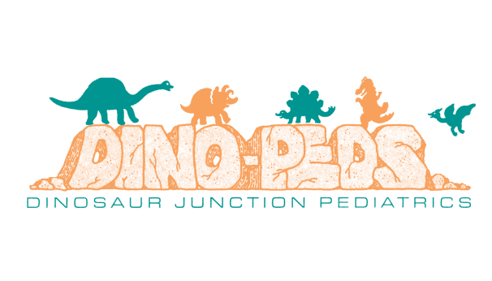

PATIENT REGISTRATION FORM
PATIENT INFORMATION

Patient's Name (Last, First, MI): ________________________________________________________________________________

Patient's Cell Phone Number: _____________________ Alternate Phone Number (□ Home or □ Work): _____________________

E-Mail Address: ___________________________________________________________________________________

Mailing Address: __________________________________________________________ Apt. # ____________

City:__________________________________ State: ________________ Zip: ___________ County: ________________

 | Date of Birth: ____________________ | Age: ______ |  | Sex: M F | Social Security Number: _______________________

INSURANCE INFORMATION
Primary Insurance: ____________________  Primary Insured Name: ________________  Policy: _____________________________  Phone Number: _____________________  Date of Birth: _______________________  Group: _____________________________  Address: _________________________________  _________________________________________ | Secondary Insurance: ____________________  Secondary Insured Name: ________________  Policy: _____________________________  Phone Number: _____________________  Date of Birth: _______________________  Group: _____________________________  Address: _____________________________________  _____________________________________________
Patient is Subscriber/Policy Holder: Y N | Patient is Subscriber/Policy Holder: Y N
ENGAGEMENT
How did you hear about our office? (Check all that apply)

[ ] Internet [ ] Billboard [ ] Radio [ ] Television [ ] Family/Friend [ ] Other:_____________

RELEASE OF INFORMATION

I hereby give permission to the person(s) listed below to receive information about the care of the above named patient.

Name(s): ______________________________________________ Relationship to Patient: ____________________________

APPOINTMENT CANCELLATION/NO-SHOW POLICY

If you wish to cancel your appointment, it must be done 24 hours in advance of the scheduled time. If you fail to make your appointment and do not call to cancel it, you will be charged $25. If you No Show the second visit, you will be charged $50. If after no-showing a third visit, you will be dismissed from the practice. This will not be paid by your insurance, and you will be fully responsible to pay it. If you no-show your first new patient visit, you will NOT be rescheduled.

Patient Signature: __________________________________________________ Date: ___________________
DINOSAUR JUNCTION PEDIATRICS

HEALTH HISTORY

Race:  [ ] American Indian/ Alaska Native  [ ] Asian  [ ] Black/African American  [ ] Hawaiian/Pacific Islander  [ ] White/Caucasian  [ ] Decline  [ ] Other: __________________ | Ethnicity:  [ ] Non-Hispanic/Latino  [ ] Hispanic/Latino  [ ] Decline  [ ] Other: _______________________

MEDICAL INFORMATION
Please note that Dino-Peds does not refill any prescriptions that are considered to be controlled substances after business hours.
Please list any MEDICATIONS patient currently takes, prescribed or over the counter.
Medication | Dosage | Route | Frequency

Any Allergies to Medication or Food (list reactions): ________________________________________________________________

Preferred Pharmacy: _________________________________________________________________________________________

Do you immunize? (Please circle one) Y N

Are you up to date on immunizations? (Please circle one) Y N

Did you receive all your immunizations in Colorado? (Please circle one) Y N

Any problems at birth? (Please circle one) Y N If yes, please describe: _______________________________

Ever had a bladder/kidney infection? (Please circle one) Y N If yes, what age? _____________________

Ever had wheezing? (Please circle one) Y N If yes, what age? ____________________________________

Any medical problems? (Please circle one) Y N If yes, please specify: ________________________________

Fractures, concussion, other serious injury? (Please circle one) Y N If yes, please specify: ________________________

Please list any SURGERIES or HOSPITALIZATIONS patient has had where the patient was admitted to the hospital. Please include age and reason for admission.

____________________________________________________________________________________________________________

____________________________________________________________________________________________________________

____________________________________________________________________________________________________________

EMERGENCY CONTACT
Name: _________________________________________________________________________________________

Relationship to Patient: ________________________ Phone Number: ________________________

HOME INFORMATION
Do you live in a [ ] house, [ ] apartment, [ ] townhouse, [ ] trailer, or [ ] other ___________?
Please list the people living in the household: ____________________________________________________________________
Name of School or Employer: ________________________________________________________________________________
Does anyone in the household smoke? (Please circle one) Y N If yes, do they smoke inside or outside? _________
Do you have animals in the home? (Please circle one) Y N If yes, what type of animal? __________________
Do you have heat with a stove or a fireplace? (Please circle one) Y N
Do you have trouble paying heat, water, or electricity bills? (Please circle one) Y N
Do you have enough food available? (Please circle one) Y N
Are there any drug or alcohol problems at home? (Please circle one) Y N
Are there carbon monoxide and fire detectors in the home? (Please circle one) Y N
Do you feel safe at home? (Please circle one) Y N

FAMILY MEDICAL HISTORY
Please place a mark or enter the information in the appropriate space regarding your child’s relative with the condition in the left-hand column.
CONDITION | PATIENT | PARENT #1 | PARENT #2 | SIBLING | GRANDPARENT OF PARENT #1 | GRANDPARENT OF PARENT #2 | OTHER
ADHD/ADD
Alcoholism
Allergies
Anemia
Asthma
Bleeding Disorder
Breast Cancer
Bronchitis
Cancer (specify)
Other Cancer (specify)
Celiac Disease
Cholesterol
Crohn's Disease
Depression
Diabetes (Child)
Diabetes (Adult)
Eczema
Emphysema
Other lung disease (specify)
Epilepsy or seizures
Gastro esophageal reflux
Heart attack less than age 50
High blood pressure
Heart disease (specify)
Lactose intolerance
Leukemia or lymphoma
Lupus
Melanoma
Migraines
Neurological disorder
Rheumatic fever or rheumatic heart disease
Rheumatoid arthritis
Schizophrenia
Stroke less than age 50
Sudden death
Low thyroid
(hypothyroidism)
Other thyroid (specify)
Other (specify)

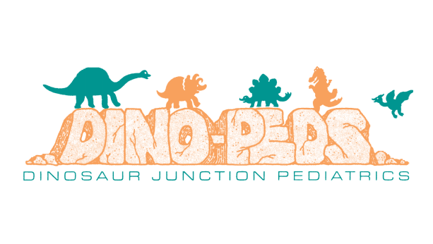

Patient Medical Packet Certification

By signing below, you agree that the above information is true and correct. You authorize Dinosaur Junction Pediatrics to leave a voicemail on the phone number(s) above unless otherwise noted. Should there be any missing information, Dino-Peds may refuse service. By signing this, you acknowledge receipt of the clinic’s Privacy Act Policy, Financial Agreement, and the CIIS Immunization Notice. This indicates we participate with Colorado prescription Monitoring Program Agreement, and Quality Health Network which is a centralized database for healthcare professionals and authorize RX prescription history consent. I hereby give a lifetime authorization for payment for insurance benefits to be made directly to Dinosaur Junction Pediatrics. I understand I am financially responsible for all charges whether or not they are covered by insurance. In the event of default, I agree to pay all costs of collections, and reasonable attorney fees. I hereby authorize this healthcare provider to release all information necessary to secure the payment benefits. I further agree that a photocopy of this agreement shall be valid as the original.

_________________________________________________________________________________________________________
SIGNATURE OF PATIENT

_________________________________________________________________________________________________________
PRINTED NAME OF PATIENT

____________________________________________________________
DATE

