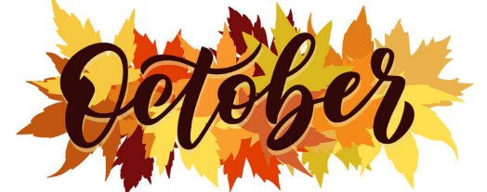

10/1-10/3
Monday | Tuesday | Wednesday | Thursday | Friday
Breakfast | Breakfast | Breakfast | Breakfast | Breakfast
Milk  Pears  Rice Chex | Milk  Bananas  Waffles | Milk  Mandarin Oranges  Toasted O’s | Milk  Bananas  Whole grain Cereal Bar | Milk  Pears  Shredded Wheat Cereal
Lunch | Lunch | Lunch | Lunch | Lunch
Milk  Chicken Alfredo  Chicken  Alfredo Sauce  Peas  Applesauce  Whole Wheat Pasta  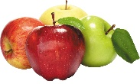 | Milk  Grilled Cheese  Tortilla  Tomato Soup  Brown Rice  Tropical Fruit | Milk  Pasta  Ground Beef  Tomato Sauce  Green Beans  Applesauce | Milk  Diced Hotdogs  Baked Beans  Peaches  Corn  Pasta Salad | Milk  Beef Tacos  Cheese  Tortillas  Diced Potatoes  Pineapple
Snack | Snack | Snack | Snack | Snack
Grape Juice  Pretzels | Apple Juice  Graham crackers | HM Grapple Juice  Animal Crackers | Apple Juice  Saltines | HM Grapple Juice  Cheese Crackers

10/6 – 10/10 and 10/27 – 10/31
Monday | Tuesday | Wednesday | Thursday | Friday
Breakfast | Breakfast | Breakfast | Breakfast | Breakfast
Milk  Pears  Toasted O’s | Milk  Bananas  Whole Grain Cereal Bars | Milk  Peaches  Corn Flakes | Milk  Mandarin Oranges  Oatmeal | Milk  Peaches  Shredded Wheat
Lunch | Lunch | Lunch | Lunch | Lunch
Milk  Pizza Rollups  Cheese  Sweet Corn  Tropical Fruit  Tortillas  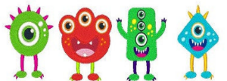 | Milk  Pasta  Ground Beef  Tomato Sauce  Green Beans  Applesauce  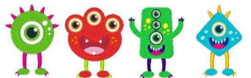 | Milk  Turkey  Tater Tots  Bananas  Whole Wheat Bread | Milk  Sloppy Joes  Ground Beef  Diced Potatoes  Applesauce  Bread | Milk  Bean Burritos  Tortillas  Peas  Cheese  Pineapple
Snack | Snack | Snack | Snack | Snack
Apple Juice  Cheese Crackers | HM Grapple  Graham Crackers | Apple Juice  Animal Crackers | HM Grapple  Club Crackers | Grape Juice  Snack Crackers

10/13 – 10/17
Monday | Tuesday | Wednesday | Thursday | Friday
Breakfast | Breakfast | Breakfast | Breakfast | Breakfast
Milk  Tropical Fruit  Corn Flakes | Milk  Bananas  Whole Grain Breakfast Bar | Milk  Peaches  Krispy Rice Cereal | Milk  Apples  Waffles | Milk  Pears  Shredded Wheat
Lunch | Lunch | Lunch | Lunch | Lunch
Milk  HM Beef Stroganoff  Ground Beef  Green Beans  Applesauce  Whole Wheat Pasta  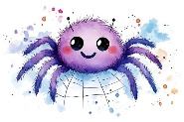 | Milk  Cream of Chicken  Chicken  Mixed Veggies  Pineapple  Rice | Milk  Beef Mac and Cheese  Ground Beef  Cheese  Sweet Peas  Pears  Whole Wheat Pasta | Milk  Diced Hotdogs  Baked Beans  Mandarin Oranges  Corn  Whole Wheat Pasta Salad | Milk  Tacos  Beef  Tortillas  Applesauce  Cheese  Peas
Snack | Snack | Snack | Snack | Snack
Apple Juice  Snack Crackers | HM Grapple  Rice Chex | Apple Juice  Saltines | HM Grapple Juice  Animal Crackers | Apple Juice  Cheese Crackers

10/20 – 10/24
Monday | Tuesday | Wednesday | Thursday | Friday
Breakfast | Breakfast | Breakfast | Breakfast | Breakfast
Milk  Peaches  Toasted Os | Milk  Bananas  Whole Grain Breakfast Bar | Milk  Peaches  Corn Flakes | Milk  Bananas  Cinnamon Biscuits | Milk  Apples  Shredded Wheat
Lunch | Lunch | Lunch | Lunch | Lunch
Milk  Sloppy Joes  Ground Beef  Pears  Green Beans  Bread  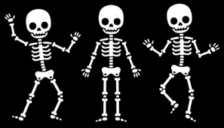 | Milk  Pizza Rollups  Cheese  Sweet Corn  Applesauce  Tortillas | Milk  Chicken and Gravy  Brown Rice  Diced Potatoes  Pineapple | Milk  Turkey Sandwiches  Tater tots  Pears  Bread | Milk  Chicken Tacos  Chicken  Mixed Veggies  Mandarin Oranges  Tortillas
Snack | Snack | Snack | Snack | Snack
Grapple Juice  Club Crackers | Apple Juice  Pretzels | Grapple Juice  Cheese Crackers | Apple Juice  Thin Wheats | Apple Juice  Snack Crackers

