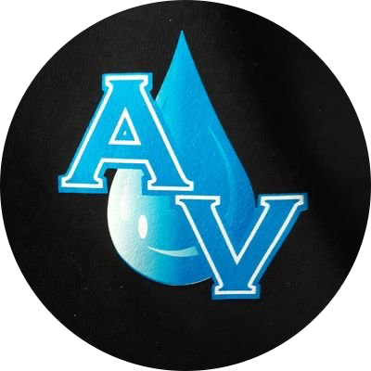

PACKAGES

Splash & Sparkle

(Great for Quick Cleanups)
💰 $200 (Small Cars) | $225 (SUVs/Trucks)
Includes:
- Exterior hand wash & dry
- Basic tire cleaning & shine
- Vacuuming (seats, carpets, trunk)
- Dashboard, console, and door panel wipe-down
- Glass cleaning (interior & exterior)
- Spray wax

Crystal Clear

(Most Popular Option)
💰 $220 (Small Cars) | $250 (SUVs/Trucks)
Includes:
- Exterior hand wash & dry
- Tire cleaning & shine
- Vacuuming & compressed air cleaning
- Shampooing carpets and floor mats
- Leather seat cleaning & conditioning or fabric seat shampoo
- Dashboard, console, and door panel deep cleaning
- Glass cleaning (interior & exterior)
- Hand wax

Aqua Shine Deluxe

(Showroom Finish)
💰 $260 (Small Cars) | $275 (Mid SUVs) | $300 (SUVs/Trucks)
Includes:
- Exterior hand wash & dry
- Clay bar treatment
- Paint polishing or single-stage correction
- Tire cleaning & shine
- Trim restoration
- Vacuuming & compressed air cleaning
- Shampooing carpets, floor mats
- Leather seat cleaning & conditioning or fabric seat shampoo
- Dashboard, console, and door panel cleaning
- Glass cleaning
- Buff

Ceramic Shine Package

(VIP Long-Term Paint Protection)
💰 $500–$1,500 (Depends on coating type and vehicle size)
Includes:
- Full exterior detail (wash, clay bar, paint correction)
- Ceramic coating (1–4 years protection)
- Tire and trim restoration
- Glass cleaning + rain-repellent treatment
- Interior wipe-down and vacuuming

Interior Revival Package

(Deep Interior Clean Only)
💰 $120–$180 (All Vehicle Types)
Includes:
- Full interior vacuum & compressed air cleaning
- Shampooing carpets, floor mats, and seats
- Steam cleaning for hard-to-reach areas
- Leather cleaning & conditioning or fabric seat shampoo
- Dashboard, console, and door panel cleaning
- Odor removal treatment
- Glass cleaning

Monthly Maintenance Plan
(For Regular Customers)
💰 $150/Visit (Small Cars) | $175/Visit (SUVs/Trucks)
Includes:
- One visit per month
- Hand wash & dry
- Vacuuming
- Dashboard & console wipe-down
- Glass cleaning
- Tire shine
- Spray wax
Program Options:
- Ultimate Aqua Maintenance
- The FreshFinish Program
- The AquaCare Club

Bark & Shine

(Full-Service Pet Hair & Odor Removal)
💰 $300 (All Vehicle Types)
Includes:
- Exterior hand wash & dry
- Basic tire cleaning & shine
- Hair removal & deep vacuuming (seats, carpets, trunk)
- Dashboard, console, and door panel wipe-down
- Glass cleaning (interior & exterior)
- Spray wax
- Odor removal treatment

Small Car
2-door, 2-seater
Examples include: Mazda Miata or Porsche Boxster

Medium car
2-door, 4-door, with back seat, average sedan
Examples include: Civic/Accord, Camry, 3 or 5 series, etc.

Large Car
4-door, big style sedan
Examples include: BMW 7 series, Toyota Avalon, Cadillac XTS

