*FESCO FENCE*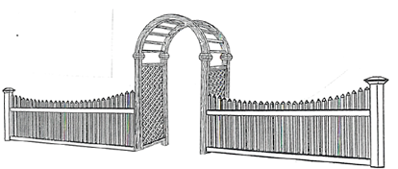

 Providing Quality & Service Since 1969

Custom Fences – Baby Barns – Decks

237 S. Rte 303, West Nyack, NY 10994

845-358-7900 [info@fescofence.com](mailto:info@fescofence.com) www.fescofence.com

7-23-25

**Fence Warranty**

Fesco guarantees our residential fences for 5 years.

You have the option of a lifetime warranty on our workmanship as long as our fence sign remains on your fence in a location visible from the road.

Non-residential fences are guaranteed for 1 year

What’s covered:

* Defects in workmanship for 5 years, upgrade to lifetime workmanship warranty as long as our sign remains on your fence in a visible location
* Gate hinges and latch adjustments
* Loose posts or naturally occurring minor Fence leaning
* Loose pickets or boards
* Self-closing gates for 2 years

What’s not covered:

* Acts of nature or abuse
* Ground settling
* Frost heave
* Mulch or other items up against the fence
* Mold or staining
* Wind damage particularly after leaving gates open

Wood fences:

* **FescoSpec** wood fences made by Fesco; material and workmanship guaranteed for 3 years
* Prefab fences are guaranteed for 1 year for material and workmanship
* Checking naturally occurs and is not covered, however complete splits through posts that are structural issues are covered
* Warping is a natural process and is not covered

Aluminum fences see the Catalyst warranty for materials coverage

MIxed Materials see the Catalyst warranty for materials coverage

Vinyl fences see the Catalyst warranty for materials coverage

Steel fences see the Ameristar warranty for materials coverage

Chain link and pipe see the Stephens Pipe & Steel warranty for materials coverage